Name: ______________________________ Period: _______________

Balancing Act
Learning Objectives:
- Describe the factors that determine whether two objects will balance each other
- Predict how changing the position of a mass on the balance will affect the motion of the balance
- Use a balance to the find the masses of unknown objects

Directions:
- Explore the Balancing Act simulation with your partner. As you explore, talk about what you find with your partner (About 5 minutes).

2. Is there more than one way to get two objects with identical masses to balance? How?

3. Next, try to get two objects with different masses to balance. Try to describe at least 2 different ways that you were able to balance them and draw them below.

Make sure you label the masses and the distance to each mass from the center (pivot point).

1. | 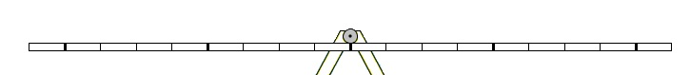
2.

5. Draw two examples of balancing a single mass on one side with two other masses

Make sure you label the masses and the distance to each mass from the center (pivot point).

1.
2.

6. For your pictures in Question 5, draw in the forces from each mass.

7. Try to draw what will happen next if the box on the left is 45 kg and the box on the right is 60 kg

8. Challenge! What is the mass of mystery object F? Explain how you determined the mass.

