Boyle’s Law: Pressure-Volume
Relationship in Gases- PhET
The primary objective of this experiment is to determine the relationship between the pressure and volume of a confined gas. Using a online simulation (screen shown in Figure 1) from the University of Colorado: PHET Simulation - Gas Properties The temperature of the gas sample and the number of molecules it contains will be kept constant. Pressure and volume data pairs will be collected during this experiment and then analyzed. From the data and graph, you should be able to determine what kind of mathematical relationship exists between the pressure and volume of the confined gas. Historically, this relationship was first established by Robert Boyle in 1662 and has since been known as Boyle’s law.
OBJECTIVES
In this experiment, you will

- Determine the relationship between pressure and volume of the gas.
- Describe the relationship between gas pressure and volume in a mathematical equation.
- Use the results to predict the pressure at other volumes.

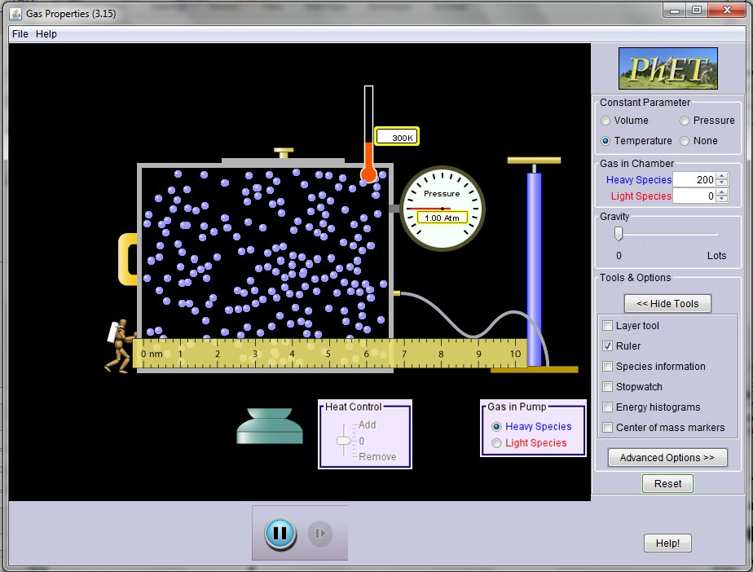
Figure 1

MATERIALS
computer
PhET Simulation – Gas Properties
Logger Pro

PROCEDURE
- Start up your browser and go to PHET Simulation - Gas Properties. Click on the “Run Now” button and after the simulation starts, select Temperature for the Constant Parameter. Click on “Show Tools” and select “Ruler”. Drag the ruler to the position shown in figure one
- We will generate data for a heavy species of gas molecules.
- Pump approximately 1 atm of pressure into the container. (Note this can be done by manually by typing in “200” for the number of heavy species gas molecules). Note the Temperature of the gas.
- Drag the handle of the box as far left as it goes. Wait for the Temperature to return to its initial value. Move the ruler to measure the size of the box and record this Length in nm and Pressure in Atmospheres (Atm) in the data table.
- Drag the handle of the box to the right 1 nm, and record the new box length in nm and pressure in Atm in the data table
- Repeat the process until you have a total of 8 data values.
- Start up Logger Pro and load the data file “Pressure_vs_box_length”. This file can be downloaded and extracted from
- http://www3.northern.edu/dolejsi/nsu_labs/Pressure_vs_Box_Length.zip
Record the values from the data table into the appropriate columns. Note that the box length is proportional to the volume of the box since this is the only dimension that is being changed.
- Examine the graph of pressure vs. box length. Based on this graph, decide what kind of mathematical relationship you think exists between these two variables, direct or inverse. To see if you made the right choice:
- Click the Curve Fit button, .
- Choose Variable Power (y = Ax^n) from the list at the lower left. Enter the power value, n, in the Power edit box that represents the relationship shown in the graph (e.g., type “1” if direct, “–1” if inverse). Click .
- A best-fit curve will be displayed on the graph. If you made the correct choice, the curve should match up well with the points. If the curve does not match up well, try a different exponent and click again. When the curve has a good fit with the data points, then click .

9. Once you have confirmed that the graph represents either a direct or inverse relationship, paste a copy of the graph below, with the graph of pressure vs. box length and its best-fit curve displayed.
10. With the best-fit curve still displayed, proceed directly to the Processing the Data section.

Graph of Pressure vs Box Length for Heavy Molecules:

DATA and calculations
Box Length  (nm) | Pressure  (Atm) | Constant, A  (P / L or P • L)
L | P | A
L | P | A
L | P | A
L | P | A
L | P | A
L | P | A
L | P | A
L | P | A

PROCESSING THE DATA
1. With the best-fit curve still displayed, choose Interpolate from the Analyze menu. A vertical cursor now appears on the graph. The cursor’s volume and pressure coordinates are displayed in the floating box. Move the cursor along the regression line until the box length value is 4.0 nm. Note the corresponding pressure value. Now move the cursor until the box length value is doubled (8.0 nm). What does your data show happens to the pressure when the volume is doubled? Show the pressure values in your answer.
P(8 nm)/P(4 nm) = P_{ratio}. This shows that when the volume doubles, the pressure choose an item.
2. Using the same technique as in Question 1, what does your data show happens to the pressure if the box length is halved from 8.0 nm to 4.0 nm? Show the pressure values in your answer.
P(4 nm)/P(8 nm) = P_{ratio}. This shows that when the volume halves, the pressure choose an item.
3. Using the same technique as in Question 1, what does your data show happens to the pressure if the volume is tripled from 3.0 nm to 9.0 nm? Show the pressure values in your answer.
P(9 nm)/P(3 nm) = P_{ratio}. This shows that when the volume triples, the pressure choose an item.
4. From your answers to the first three questions and the shape of the curve in the plot of pressure vs. volume, do you think the relationship between the pressure and volume of a confined gas is direct or inverse? Explain your answer.
The relationship between pressure and volume is choose an item. This is because the graph shows choose an item in pressure as the volume increases. The first three questions show that changes in the pressure and volume are choose an item.
5. Based on your data, what would you expect the pressure to be if the volume of the syringe was increased from 2.0 nm to 8.0 nm? Explain or show work to support your answer.
P(8.0 nm)/P(2.0 nm) = P_{ratio}. This shows that when the volume quadruples, the pressure choose an item.
6. Based on your data, what would you expect the pressure to be if the volume of the syringe was decreased from 8.0 nm to 2.0 nm? Explain or show work to support your answer.
P(2.0 nm)/P(8.0 nm) = P_{ratio}. This shows that when the volume decrease by a factor of 4, the pressure choose an item.
7. What experimental factors are assumed to be constant in this experiment?
The two experiment factors that were kept constant were choose an item and choose an item.
8. One way to determine if a relationship is inverse or direct is to find a proportionality constant, A from the data. If this relationship is direct, A = P/V. If it is inverse, A = P•V. Based on your answer to Question 4, choose one of these formulas and calculate k for the eight ordered pairs in your data table (divide or multiply the P and V values). Show the answers in the third column of the Data and Calculations table.
9. How constant were the values for A you obtained in Question 8? Good data may show some minor variation, but the values for A should be relatively constant.
The average value of A was A_{ave}. and the difference between the largest and smallest value was difference.
10. Using P, V, and A, write an equation representing Boyle’s law. Write a verbal statement that correctly expresses Boyle’s law.
Choose an item.
EXTENSION
1. To confirm the type of relationship that exists between pressure and volume, a graph of pressure versus the reciprocal of length (1/length or length-1) may also be plotted. To do this using Logger Pro, it is necessary to create a new column of data, reciprocal of length, based on your original volume data.
- Remove the Curve Fit box from the graph by clicking on its upper-left corner.
- Choose New Calculated Column from the Data menu.
- Enter “1/Length” as the Name, “1/L” as the Short Name, and “1/nm” as the Unit. Enter the correct formula for the column (1/volume) into the Equation edit box. To do this, type in “1” and “/”. Then select “Length” from the Variables list. In the Equation edit box, you should now see displayed: 1/“L”. Click .
- Click on the horizontal-axis label, select “1/Length” to be displayed on the horizontal axis.

2. Decide if the new relationship is direct or inverse and change the formula in the Fit menu accordingly.
- Click the Curve Fit button, .
- Choose Variable Power from the list at the lower left. Enter the value of the power in the edit box that represents the relationship shown in the graph (e.g., type “1” if direct, “–1” if inverse). Click .
- A best-fit curve will be displayed on the graph. If you made the correct choice, the curve should match up well with the points. If the curve does not match up well, try a different exponent and click again. When the curve has a good fit with the data points, then click .

3. If the relationship between P and L is an inverse relationship, the plot of P vs. 1/L should be direct; that is, the curve should be a straight line passing through zero and pass through (or near) your data points. Examine your graph to see if this is true for your data.
Choose an item, the relationship between P and 1/L appears to be a direct proportion for my data with a Root Mean Square Error (RMSE) of RMSE.
4. Paste a copy of the graph below.
Graph of Pressure vs 1/length for heavy molecules:

concluSION
After group discussion, write a conclusion summarizing the results of this experiment.

Click here to enter Conclusion.

