NSU Phys Lab: Ohm’s Law using a PhET Simulation

The fundamental relationship among the three important electrical quantities current, voltage, and resistance was discovered by Georg Simon Ohm. The relationship and the unit of electrical resistance were both named for him to commemorate this contribution to physics. One statement of Ohm’s law is that the current through a resistor is proportional to the voltage across the resistor and inversely proportional to the resistance. In this experiment you will see if Ohm’s law is applicable by generating experimental data using a PhET Simulation:
http://phet.colorado.edu/en/simulation/ohms-law
Current and voltage can be difficult to understand, because they cannot be observed directly. To clarify these terms, some people make the comparison between electrical circuits and water flowing in pipes. Here is a chart of the three electrical units we will study in this experiment.
Electrical Quantity | Description | Unit | Water Analogy
Voltage or Potential Difference | A measure of the Energy difference per unit charge between two points in a circuit. | Volt (V) | Water Pressure
Current | A measure of the flow of charge in a circuit. | Ampere (A) | Amount of water flowing
Resistance | A measure of how difficult it is for current to flow in a circuit. | Ohm (Ω) | A measure of how difficult it is for water to flow through a pipe.

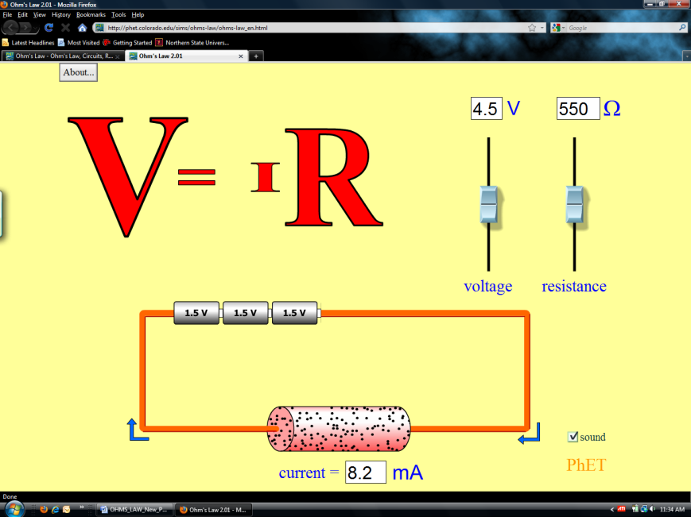
Figure 1
objectives
- Determine the mathematical relationship between current, potential difference, and resistance in a simple circuit.
- Examine the potential vs. current behavior of a resistor and current vs. resistance for a fixed potential.

MATERIALS
computer
PhET Simulation – Ohms Law
Logger Pro from Vernier Software

PRELIMINARY SEtup and QUESTIONS
1. Start up you Internet browser. Start up the PhET Simulation at http://phet.colorado.edu/en/simulation/ohms-law. Click on the “Run Now” button. The screen shown in Figure 1 should appear. Minimize your browser.
2. Start up Logger Pro. Download the following zip file and extract the contents.
http://www3.northern.edu/dolejsi/nsu_labs/Ohms_Law_PhET.zip
Open the file “Ohms_Law-PhET”. A graph of potential vs. current will be displayed. Minimize Logger Pro and switch back to the PhET ohms law simulation.
3. With the Resistance slider set at its default value, move the potential slider, observing what happens to the current.
If the voltage doubles, what happens to the current?
Click here to enter text.

What type of relationship do you believe exists between voltage and current?
Click here to enter text.

4. With the Voltage slider set at 4.5 V, move the resistance slider, observing what happens to the current.
If the resistance doubles, what happens to the current?
Click here to enter text.

What type of relationship do you believe exists between current and resistance?
Click here to enter text.

PROCEDURE
- Set the Resistance slider to 300 ohms, Use the Voltage slider to adjust the Potential to the values in data table 1, also recording the resulting electric currents.

Data Table 1:

Resistance R = Click here to enter. Ω

Current (mA) | Potential | Current (mA) | Potential
 | 1.5 |  | 6.0
 | 3.0 |  | 7.5
 | 4.5 |  | 9.0

Slope of graph = Click here to enter. V/mA.

Slope times x 1000 = Click here to enter. Ω

% Error of Slope times 1000 with R = Click here to enter. %

Minimize your internet browser and switch up Logger Pro. Enter your data from Table 1 under Data Set 1. Perform a “linear fit” on the data. A sample graph is shown below:

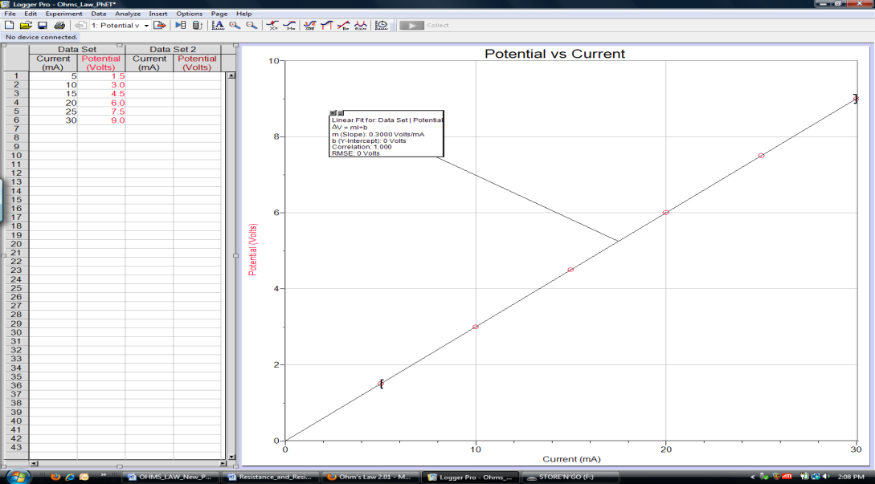

Record the slope of the graph below data table 1. Calculate the resistance value by taking the slope of the graph times 1000. Compare the slope times 1000 value with the value of the resistance set in the simulation by calculating a % error.

- Switch back to the PhET Simulation. Set the Resistance slider to 600 ohms, Use the Voltage slider to adjust the Potential to the values in data table 2, also recording the resulting electric currents.

Data Table 2:

Resistance R = Click here to enter. Ω

Current (mA) | Potential | Current (mA) | Potential
 | 1.5 |  | 6.0
 | 3.0 |  | 7.5
 | 4.5 |  | 9.0

Slope of graph = Click here to enter. V/mA.

Slope times x 1000 = Click here to enter. Ω

% Error of Slope times 1000 with R = Click here to enter. %

Minimize your internet browser and switch up Logger Pro. Enter your data from Table 2 under Data Set 2. Perform a “linear fit” on the data. Record the slope of the graph below data table 2. Calculate the resistance value by taking the slope of the graph times 1000. Compare the slope times 1000 value with the value of the resistance set in the simulation by calculating a % error.
Paste the resulting graphs for both data sets with fits showing:

Does a linear Function work well with both data sets of ΔV vs I data? Click here.

- Switch back to the PhET simulation. Return the Voltage Slider to 4.5 V. Now we will use the Resistance slider to set the Resistor to the values in the table. Fill in table 3 with your data:

Data Table 3:

Electric Potential ΔV = Click here to enter Volts

R (ohms) | Current (mA) | R (ohms) | Current (mA)
100 |  | 600
200 |  | 700
300 |  | 800
400 |  | 900
500 |  | 1000

Inverse Fit Constant of graph of I vs R = Click here to enter ΩmA.
Fit Constant divided by 1000 = Click here to enter Volts
% Error of Fit Constant divided by 1000 with ΔV = Click here to enter %

Switch to Logger Pro. Go to page 2 on the Logger Pro display. Enter your Resistance and Current values from Table 3 in Data Set 3.

Using Curve Fit, try fitting this data to an “Inverse” function. Paste this graph with the fit showing:

Calculate the Battery Voltage of the by taking the Inverse fit constant divided by 1000. Compare this computed value with the value of the battery voltage set in the simulation by calculating a % error.

Does an inverse function provide a good fit to your data? Click here.

ANALYSIS
Do the experimental data confirm that the Electric Current in a resistor is directly proportional to the electric potential provided by the batteries?

Click here to enter text.

Do the experimental data confirm that the electric current is inversely proportional to the Resistance for a fixed electric potential?

Click here to enter text.

concluSION
After group discussion, write a conclusion that summarizes the results of this experiment.

Click here to enter conclusion.

