The Moving Man

Introduction
In this activity you will investigate the physical science of motion. The Moving Man sim will be used to test and observe position and velocity. Position is a specific area occupied by a physical object. Velocity is the speed at which the physical object moves (distance/time).

1. Click this link: http://phet.colorado.edu/
This is a screen shot of the website:

2. Click on “Play with sims”.
3. Click “Physics” -> Click “Motion”->Click “The Moving Man”->Click “Run Now!”
4. Wait for the simulation to load and then the following screen will appear: 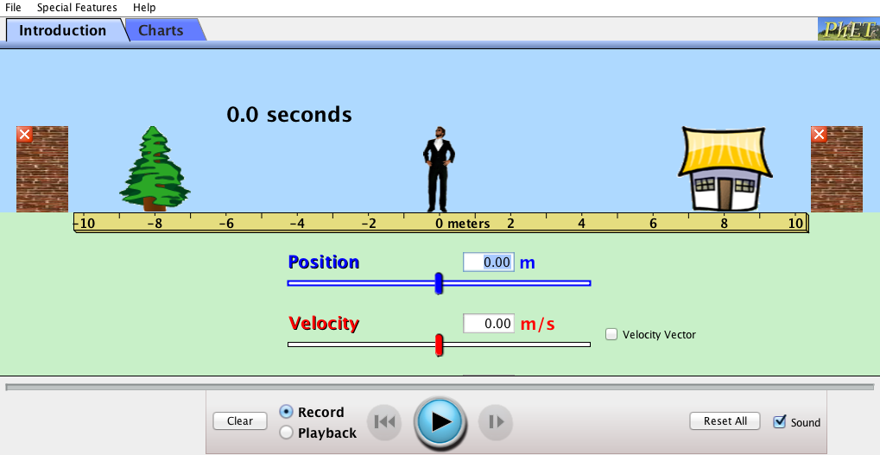
In order to compete the activity switch between this document and the sim that goes along with it.

Exploration Phase
1. Click the “Introduction” tab on the sim (top left corner)
2. Notice the placement of the objects on the screen (house, tree and two brick walls).
3. The moving man will be at 0 meters, drag him back and forth at different speeds and notice the changes in position and velocity shown on the bars just below the ruler.
4. After playing with the moving man press the pause button on the bottom of the page, click play back press play and watch the movements you have just made with the man. Use the playback video to answer the questions below.

Questions

- When at a position of 0 meters and observing the position bar below the ruler, what do you notice about the position number as you move the man towards the house? How about as you move the man towards the tree?

- When at a position of 0 meters also observe the velocity bar. What do you notice about the velocity number as the man moves towards the house? How about as the man moves towards the tree?

- Thinking about position and direction why do you think the numbers for position and velocity moved into negative numbers when the man was moved in a certain direction?

- Now that you have observed the different movements look at the ruler and the different intervals it shows. What do you think the meaning of a position of 0 means?

Explanation Phase

Aim: Create rules that relate the position, time and velocity to one another.

Click on the “Charts” tab and click the orange minus box next in the acceleration box as we will not use that graph for this lesson. Once you are done your screen should look like this:
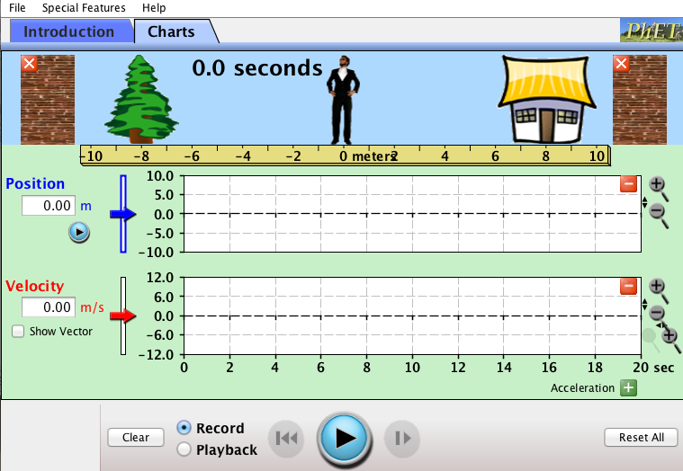
Here is some reference information:

The right side of the ruler where the house is shows us the positive direction of movement.
The left side of the ruler where the tree is shows us the negative direction of movement.

Use the simulation to now create the rules that relate position, time and velocity with one another. Be sure to observe the unit for velocity (m/s), which shows us how far an object will move (meters) in a specific amount of time (seconds). This will help create the different rules.

For example: If the position increases and time remains constant then the velocity will ______________.
Use this example to create a rule for each scenario (increasing, decreasing and moving at a constant rate) involving position, time and velocity.

Describe the rules here (and have it checked by the instructor):

Based on the rules you have created and the unit/equation for velocity answer the questions/fill in the blanks below:

If we know the velocity of a moving object is meters(distance)/seconds(time) is it possible to create an equation for the value of meters(distance)? For seconds (time)?

If so what are these equations?

Choose one of the answers provided to fill in the blanks:

If the man is moving from a position of 0 to 6 meters in 3 seconds he will move ______________________ than moving from a position of -4 to 0 meters in 3 seconds.
Answers: steady, slower, faster

Looking at the position of the house and tree if the man ran starting from the house going to the tree in 8 seconds the velocity would be __________________.
Answers: 2m/s, 3m/s, 5m/s

Starting at the reference position of 0, if the man is moving at a velocity 2m/s it will take __________6s______ for him to reach a position of 12m?
Answers: 7s, 6s, 9s

Take a screenshot of what this graph will look like and place it below:
For mac users press command, shift and 3 at the same time to get a screenshot.

Application Phase

Click clear and enter a value of 0 for both the position and the velocity.

Again play with the simulation and observe the graphs for both position and velocity. Playback the clip and explain the movement of the lines on the position graph and the velocity graph below:

What do you think these different movements mean?

Close out the velocity graph tab in order to focus on the position graph. Create two of your own position graphs based on the information provided. Be sure to screenshot these graphs and place them into the document.
Graph A: The moving man starts at a position of -4 meters at a stand still for 2 seconds. The man then quickly moves to 2 meters, then slowly moves to 8 meters and lastly makes a quick move back to the starting position of -4 meters.

Graph B: The moving man starts at a position of 0 meters. The man slowly moves to a position of -5 meters, then quickly moves to a position of 4 meters, then slowly back to a position of 0 meters and lastly quickly to 2 meters.

Look at the position graphs below and describe the motion of the moving man.
Be sure to include the information about the starting position, ending position and time.
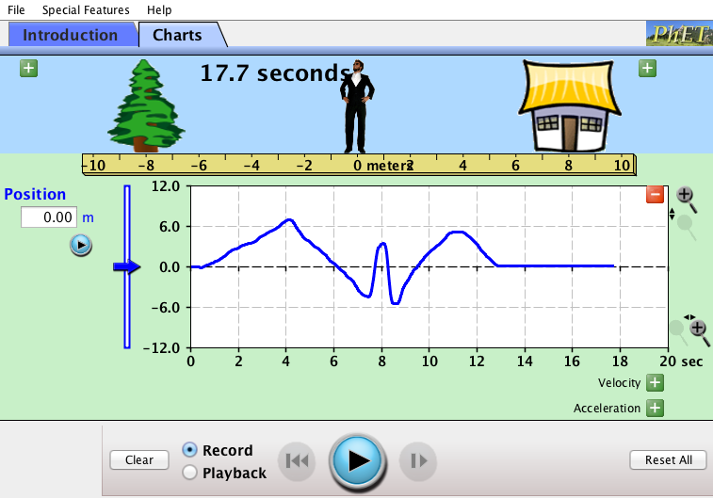
Graph Description:

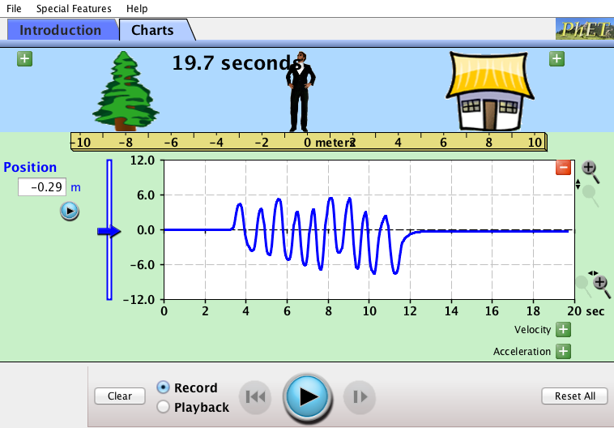
Graph Description:

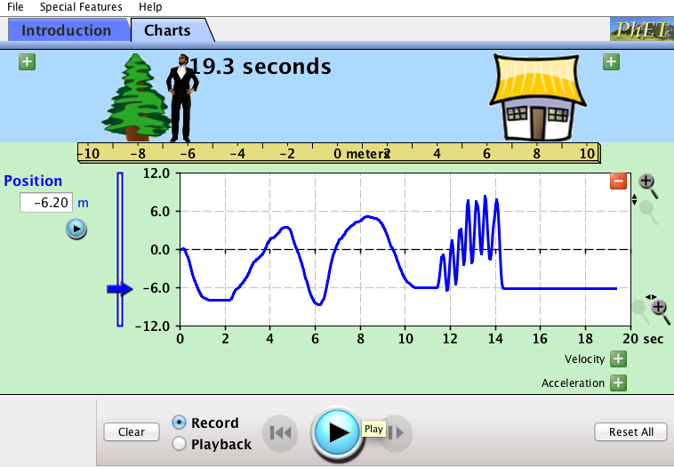
Graph Description:

Conclusions: Explain how playing with The Moving Man simulation helped you to learn more about position and velocity:

Finished: Congratulations. You are now in motion!

