Title: Forces, Friction and Motion

Introduction
Today we will learn about how the force put on an object determines how it will move when there is no friction and when there is friction.

- Click this link: http://phet.colorado.edu/en/simulation/forces-and-motion-basics

This is a screen shot of the website:
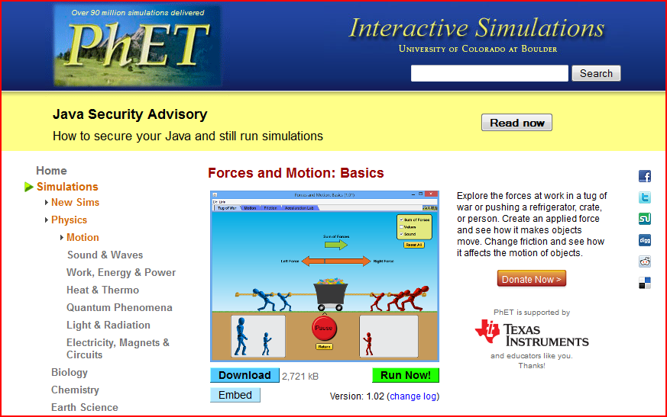

- Click the button that says “Run Now”. It might take a few minutes to load.
The screen will look like this:
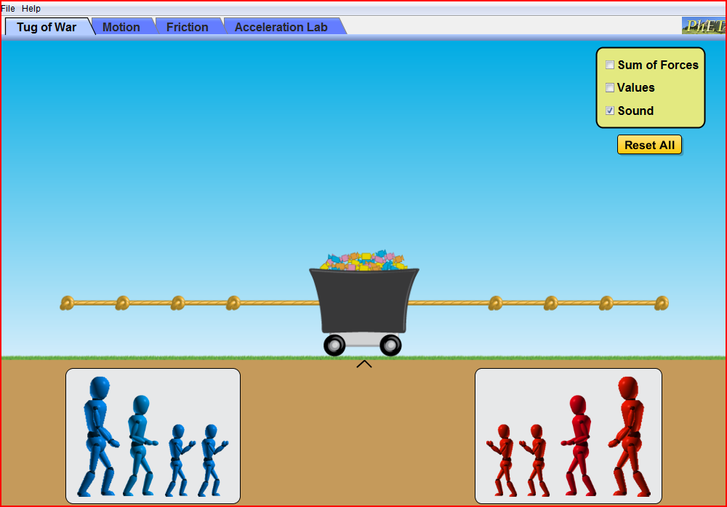

- All answers will be recorded on this document. You will have to switch between the document and the forces and motion simulation in order to complete all parts of the activity.

Explore

- Place a man on each side of the rope.
- Hit the “go” button.
- Hit the “Return” button. Try it again with either the same amount of men on each side or a different amount of men on each side.
- Hit the “Reset all” button. Click box next to “sum of forces” and “values,” continue putting men on each side.
- Hit the “Return” button.

Questions ( answer each question in the space provided)

- How can you make the blue side win?

- How can you make the red side win?

- How can you get a tie on both sides?

- Repeat step 4. Come up with a number sentence or equation we can use to find the sum of the forces.
Here are a few suggestions.
Fapplied - Ffriction
Fapplied + Ffriction

- If there was only one man pulling the cart what would the sum of forces be?

Explain

Title: Forces, Friction, and Motion
Aim: How does applied force and friction affect the speed of an object?

The science concept is: If Sum of forces are not zero, object speeds up or slows down. If zero then its speed is constant.

Part I- Motion
- Click the tab “Motion”
- Check the boxes next to “ force, values, masses, and speed”
- Click the pause button.
- Place a box on the skateboard. Type 200 in the box. The screen should look like this:
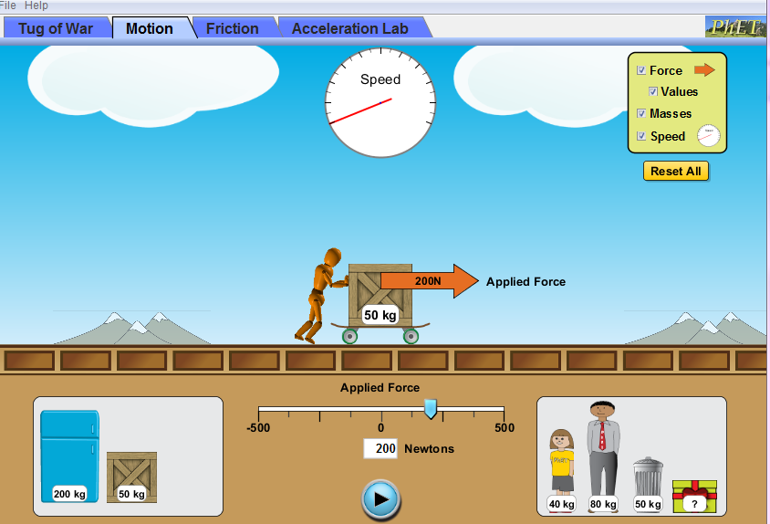

- Press the play button. Count to ten, what happens? (Look at the speedometer)

- Repeat steps 4 and 5 with the refrigerator. (look at the speedometer)

- Click the “Reset All” button.
- Repeat steps 2-4 using different objects and different applied forces. You can also use the people.
- What happens to the speed, does it slow down as different objects are added and the applied force is different?

- Why do you think this happens?

- Is there a sum of forces?

- How much time does it take for 1 crate, 2 crates, a refrigerator, the man, the girl, and the mystery object, with same applied force get to maximum speed? Maximum speed is reach when the hand on the speedometer cannot go any further. (Record your answers in table below.) Open a new browser and type in this link to use the stopwatch. http://www.online-stopwatch.com/full-screen-stopwatch/ 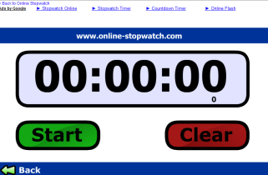

Object | Mass | Applied force (Newtons) | Time (Use stopwatch)
1 crate |  | 300N
2 crates |  | 300N
Refrigerator |  | 300N
Man |  | 300N
Girl |  | 300N
Mystery Object |  | 300N

- Do you think the object’s mass determines how long it will take for that object to reach maximum speed with an applied force of 300 N? Yes or No, Explain your answer.

- How much do you think the mystery object weighs based on how long it took to reach maximum speed at 300N?

Part II-Friction
- Click the tab “Friction”
- Check the boxes next to “ forces and speed”
- Place the refrigerator on the screen. Type 500 in the box. The screen should look like this:
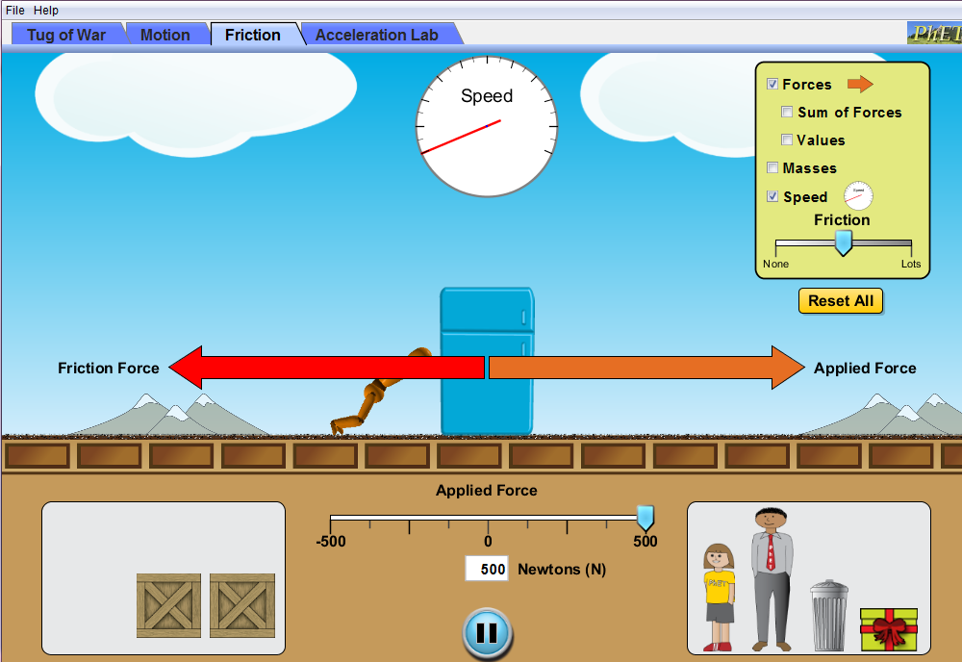

- What happened? Did the refrigerator move?

- Click the “Reset All” button.
- Check the boxes next to “values and speed”
- Place the refrigerator on the screen. Type 500 in the box. Slide the friction tab toward “None”.
- What happens as you slide the fiction tab closer to “None”?

- Click “Reset All”.
- Check the boxes next to “values and speed”
- Place any object on the screen. You can also place the people on the screen.
- Type 500 in the box. Slide the friction tab toward “None” or “Lots”. Stop the friction tab where the friction force arrow is between 100N and 200N.

- Complete the table. Fill in the missing values.
Object | Applied Force (N) | Friction Force (N) | Sum of Forces (N)
Crate | 200 | 125
Man | 472 |  | 272
Refrigerator |  | 51 | 99
Girl | 363 | 100
Garbage Can | 500 |  | 375
*You can use the Friction Tab to help you check your answers.

- Calculate the Sum of Forces using the number sentence or equation you came up with on the first page.

- Click the “Sum of Forces” box. Did you get the same number using your number sentence or equation?

- If you did not, how can you revise your number sentence or equation to match the Sum of Forces provided on the screen?

Apply

Now we will call all applied forces positive and all friction forces negative.

Use the equation to complete the table. Fill in the missing values.
Object | Applied Force (N) | Friction Force (N) | Sum of Forces (N)
Box |  | -210 | 190
Man | 350 |  | 274
Refrigerator |  | -137 | 363
Girl | 200 |  | 122
Garbage Can |  | -50 | 100
Mystery Object | 300 |  | 175

- How does the force placed on an object affect how it moves?

- What happens if there is too much friction? Will the object move slowly, fast or not at all?

- What if only a little friction is added, how will the object move?

The END!! Congratulations you are finished.

