Masses and Springs: Total Energy
Intro
In this simulation we will be investigating the relationship between kinetic energy, potential energy, thermal energy, and total energy regarding springs.
1. Click on the link: http://phet.colorado.edu/en/simulation/mass-spring-lab
This is a screenshot of the website:

2. Click the “Play with Sims” button.
3. Click “Physics” > “Masses and Springs”
This is a screenshot of the simulation page
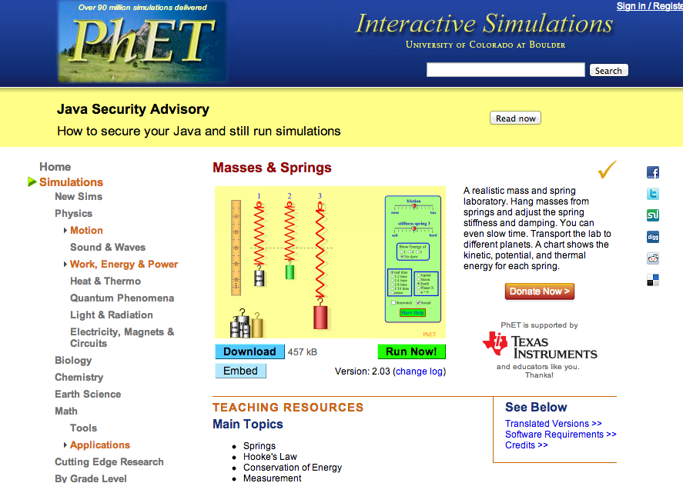
4. When you see this, Click “Run Now!”
5. Switch between this document and the simulation “Masses and Springs” to complete this activity.

Explore
Take 5 mins and freely explore the sim.

Close the sim and open it again.
1. When you open the activity, click “3” in the “show energy of” box.
2. Slide friction to “none”
3. In the bottom left box, click “pause”.
4. Place the Yellow weight onto spring 3.
4. Use the provided ruler, move it to the energy meter.
(*keep in mind, ruler is upside down, so: 50 =10, 40 = 20, 30 = 30, 20 = 40, 10 = 50, top = 60)
5. Use the picture below as a reference.
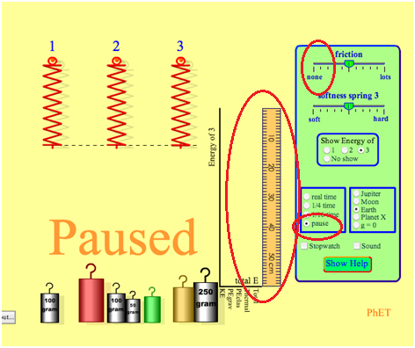
Using the ruler to measure:
What is the energy of PEgrav?

What is the total energy?

Now, press 1/16 time and watch what happens.

Explain
Energy
1. what did you notice?

2. As the mass moves down, what happens to KE? PE elas? Total?

3. At what point in the motion is KE at its greatest value? Least? (use words: TOP, BOTTOM, MIDWAY)
Greatest
Least

4. At what point in the motion is PEgrav at its greatest value? Least? (use words: TOP, BOTTOM, MIDWAY)
Greatest
Least

5. At what point in the motion is PEelas at its greatest value? Least? (use words: TOP, BOTTOM, MIDWAY)
Greatest
Least

Total Energy
Press pause and move the yellow object back to the neutral position on spring 3.
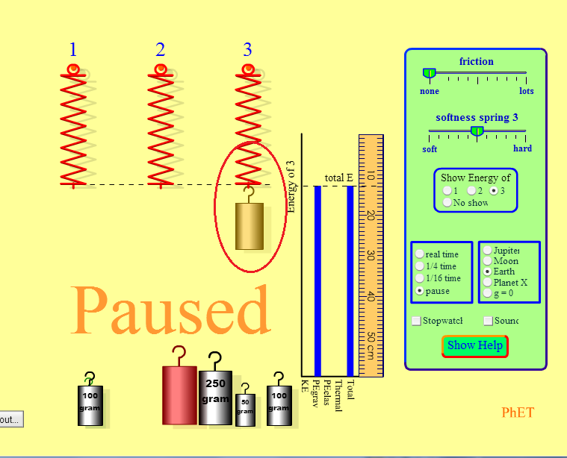
Press 1/16 time.
Pause the sim midway as the mass moves DOWN.
Use the ruler to find the totals of:
KE _____
PEgrav _____
PEelas _____
Total _____

Pause the sim midway as the mass moves UP.
Use the ruler to find the totals of:
KE _____
PEgrav _____
PEelas _____
Total _____

Gravity
1. With the sim still paused, change the gravity to: Jupiter, Moon, Earth, Planet X, and g=0.

2. What effect does gravity have on energy values?

3. Which values increase or decrease?

4. Rank them in order from greatest total energy to least total energy.
a. b. c. d. e.

5. How can you explain this phenomenon?

Apply

1. If total energy were not a meter in the sim, how could we find the value of total energy?

2. Using what we have learned about total energy, fill out the chart below:

Mass | KE | PE grav | PE elas | Total
100g | 3 | 23 | 4

Bonus
1. There is a mass placed on spring 3. using the information in the table, find the missing values.
Take a screenshot of the mass in starting position, then fill out the chart below:

Gravity | Mass | KE | PE grav | PE elas | Total
 |  | 3 |  | 11 | 39

