Joyce Kechner

Title: States of Matter
Introduction:
In this activity you will investigate the states of matter and the changes that occur to particles. In order to change states of matter you will heat and cool particles.

- Click on the link: https://phet.colorado.edu/en/simulation/states-of-matter-basics

This is a screen shot of the website: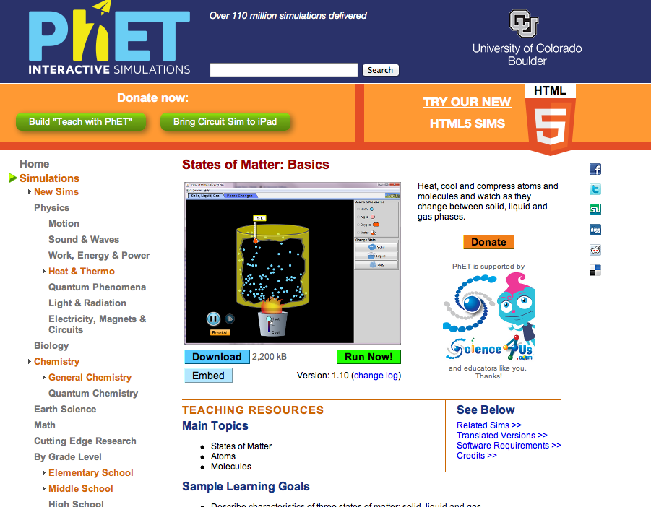

- Click “ Run Now!”
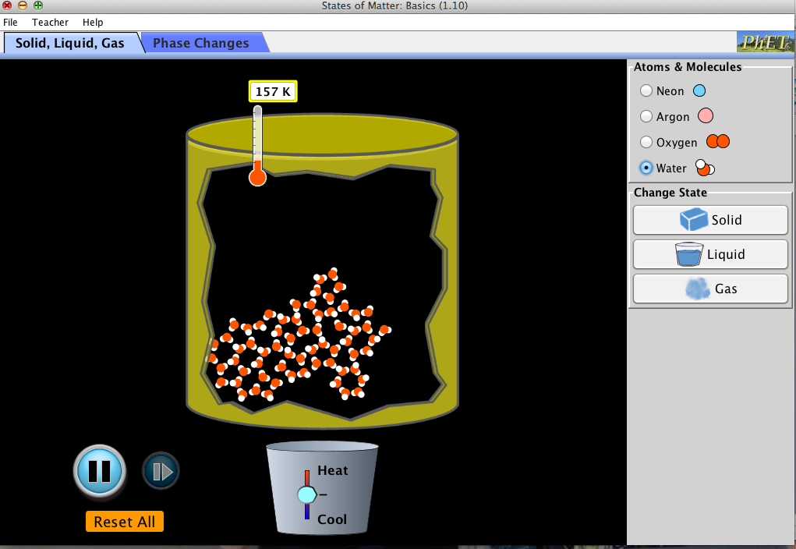
It will take time to load and then the screen will look like this:
- Click “Teacher-> Celsius

You will switch between this document and the States of Matter sim to complete the activity

Exploration Phase:
- Click on the different atoms and molecules to view what they look like when they are solids, liquids, and gases.
- Explore freely heating and cooling the different atoms and molecules and observing their temperatures and positions.

Questions:
- Sketch a picture of what the neon atoms look like when they are a solid:

- How do the neon atoms look when they are a liquid?

- When you heat the solid oxygen atoms, how does their position change?

Explanation Phase:
Aim: Create a rule that explains what happens to the position and speed of particles when temperature increases or decreases.

Click on the “Reset All” button.

Use the Sim and fill in the blanks of the following table:
Atoms and Molecules | State of Matter | Temperature | Sketch Picture
Oxygen | Liquid
Oxygen | Gas
Oxygen | Solid

Write rule here:
When temperature decreases the particles….
When temperature increases the particle….

Application Phase:

Use the information you know from the table above fill out the following table without using the Sim.

Atoms and Molecules | State of Matter | Temperature | Sketch Picture
Water | Liquid
Water | Gas
Water | Solid

When your finished, check your predictions using the Sim. Make any changes needed to your table.

Conclusion:
Based on the data in your table and what you saw when using the Sim to check your work, make any chances necessary to your existing rule.
Write your final rule here:

Congrats! You’re finished!

