PreAP Physics – Energy Skate Park PhET Lab
Today, you will use the Energy Skate Park Lab to explore energy transformations and determine how the position of a skater affects his speed and potential and kinetic energies.
Beginning Observations
1) Open the Energy Skate Park PhET Simulation. What can you change about the simulation?

2) On the track of your choice, select “Show Pie Chart” What three types of energy are show in the chart? Write the three types and their definitions below.

Part 1 – Energy Transformations
1) Create your own track or select one of the premade tracks. Draw four points on your track that you would like to investigate.

2) Fill in the predictions column by sketching what you think the Energy pie chart will look like for the ball at your four points. Then, use the simulation to test your ideas and explain any differences.
Point | Prediction | Simulation | Explain Differences
1
2
3
4

3) The Law of Conservation of Energy states that energy cannot be created or destroyed. Therefore, energy can only be transformed. Use this statement to answer the questions that follow.
a) What type(s) of energy did the skater have at the skater’s highest point?

b) What type(s) of energy did the skater at his lowest point?

c) What type of energy transformation did you see between the highest and lowest point in the motion of the skater?

Part 2 – Relating Speed to Potential and Kinetic Energy
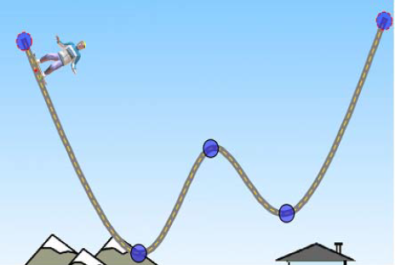
4) Label on the track where you predict the skater will is

a) at his maximum speed
b) stopped
c) going his average speed
d) going slow
e) going fast

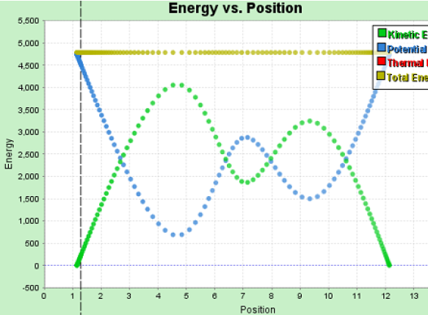
5) On the graph to the right label where you predict the skater is
a) at his maximum speed
b) stopped
c) going his average speed
d) going slow
e) going fast

6) Test your ideas using the Double Well Roller Coaster track.
a) Make any modifications to your answers in RED on the images for Questions 4 and 5.
b) If one of your friends asked you for help in making sense of the type of graph in Question 4. How would you explain what it is showing? *Consider: What is on each axis? What types of energy are being graphed?

c) Using the graph in Question 5, what can you say about the total energy of the skater?

Post Lab
7) The diagram below shows a frictionless track.
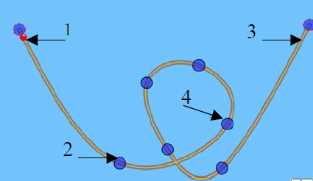

Assume a skater were to complete the track. At which positions is the sum of the potential and kinetic energy of the same? Explain.

8) Using the diagram in Question 7, assume that the skater moves from point 1 to point 2. What type of energy transformation would exist in the movement between those two points?

