Name _____________________________________________________________ Date_____________________

I. What is a Fraction?
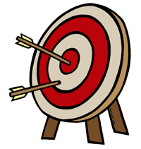
Lesson Objective: We will be able to explain the meaning of the top and bottom numbers in a fraction.

- Explore: Take 5 minutes to explore the sim before beginning this worksheet.

First Tab: Intro
Check that the “Max” button is set on 1.
2. Choose a representation and make a fraction. Then write and sketch the fraction.
Fraction Name:
Sketch/Drawing:

- Increase or decrease the top number of the fraction. What happens? Write and sketch the new fraction.

Fraction Name:
Sketch/Drawing:

- Go back to your original fraction (from #2). Increase or decrease the bottom number of the fraction. What happens? Write and sketch the new fraction.

Fraction Name:
Sketch/Drawing:

- Try different representations.
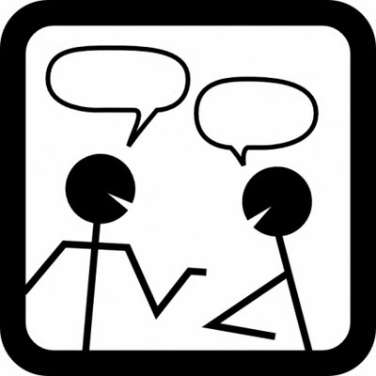
- Think-Pair-Share:

- How would you describe the top number of a fraction? How does changing the top number change the amount? Do you and your partner agree on the meaning of the top number?

- How would you describe the bottom number of a fraction? How does changing the bottom number of a fraction change the amount? Do you and your partner agree on the meaning of the top number?

Second Tab: Build a Fraction

- Click on the second tab. Select “Level 1” in the top row to begin the activity. Using your knowledge of the top/bottom numbers in a fraction, build fractions that match the numeric representations.

