TITLE
Saturated Solutions

AUTHORS
Ted Clark (The Ohio State University)
Julia Chamberlain (University of Colorado Boulder)

COURSE
General Chemistry

TYPE
Interactive Lecture Demonstration Guide

TEACHING MODE
Lecture Demonstration

LEARNING GOALS
Students will be able to:
- Compare and describe saturated and unsaturated solutions at the particle-level, and in terms of macroscopic observations.
- Explain how and whether changes in solute amount and changes in volume affect the concentration of unsaturated and saturated solutions.
- Relate the maximum concentration of saturated solutions (at a particular temperature) to the identity of the solute.

COPYRIGHT
This work is licensed under a Creative Commons Attribution 4.0 International License.
This license allows users to share and adapt the materials, as long as appropriate attribution is given (with a link to the original), an indication if changes have been made, and an indication of the original licensing.
Saturated solutions

Placement in course
Start of the 2nd semester of General Chemistry.
Solutions and solution stoichiometry have been introduced. Students may have some understanding of the energetics of solution formation and the dynamic equilibrium that exists for a saturated solution. States of matter and phase changes have been introduced.

Prior knowledge
- Solute & solvent
- Concentration calculations involving molarity
- Dilutions
- Phase changes, evaporation

Learning objectives:
Simulation | Format | Objectives, concepts
Salts & Solubility | Instructor-led | - Compare and describe saturated and unsaturated solutions at the particle-level, and in terms of macroscopic observations.
Concentration | Instructor-led | - Explain how and whether changes in solute amount and changes in volume affect the concentration of unsaturated and saturated solutions.
Molarity | Instructor-led | - Relate the maximum concentration of saturated solutions (at a particular temperature) to the identity of the solute.

Resources
Salts & Solubility: http://phet.colorado.edu/en/simulation/soluble-salts
Concentration: http://phet.colorado.edu/en/simulation/concentration
Molarity: http://phet.colorado.edu/en/simulation/molarity

Keywords
Solute, solvent, solution, saturated, unsaturated, supersaturated, concentration, molarity

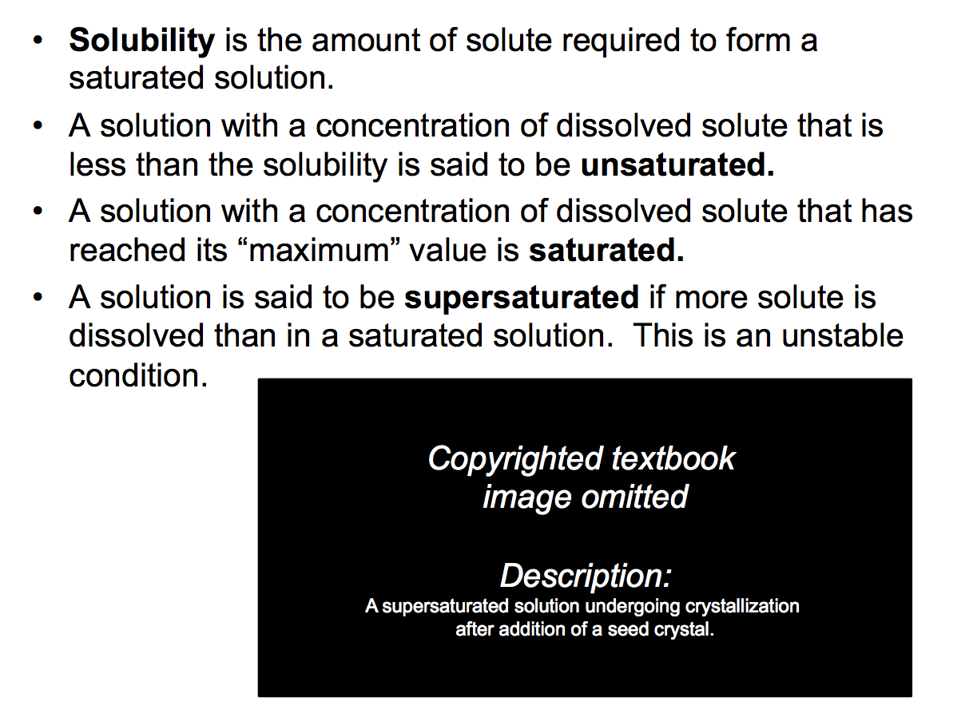
Slide 1: The terms unsaturated, saturated, and supersaturated are introduced.

A demonstration can support the initial discussion, e.g. have three different sodium acetate solutions to which sodium acetate solid is added. Based on initial observations, which solution is saturated? Add a seed crystal to each to distinguish between the unsaturated and supersaturated solutions.

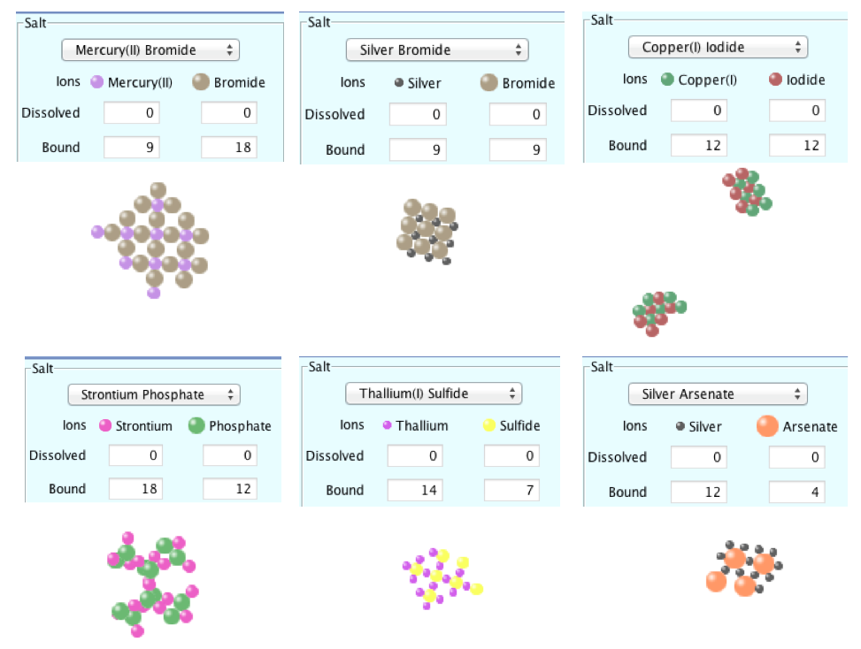
Slide 2:
The Slightly Soluble Salts tab of the sim Salts and Solubility is used.

Describe for the class that, in this sim, you control a “microscopic salt shaker” that will add salt to water and that different salts may be selected (these are shown in slide 2).

- Based on the name of a particular salt, students can be asked to write the formula.

- With the sim paused it is possible to shake the shaker and examine representations of each ionic solid.

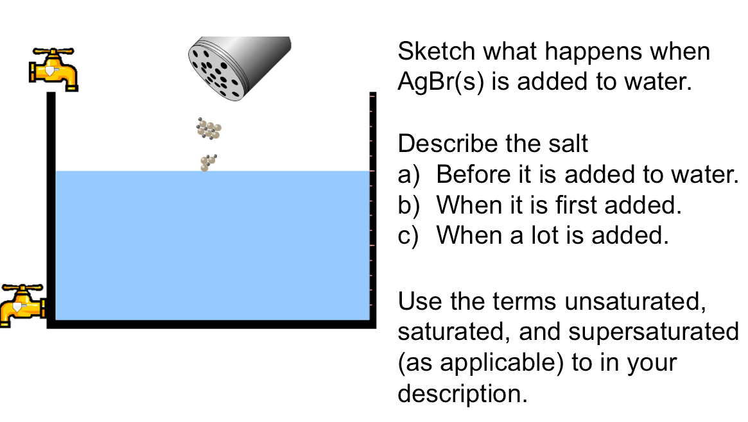
Slide 3: Allow students to make initial predictions and then investigate with the sim.
Notice that, within the sim, it is possible to select salts with cation:anion ratios other than 1:1.

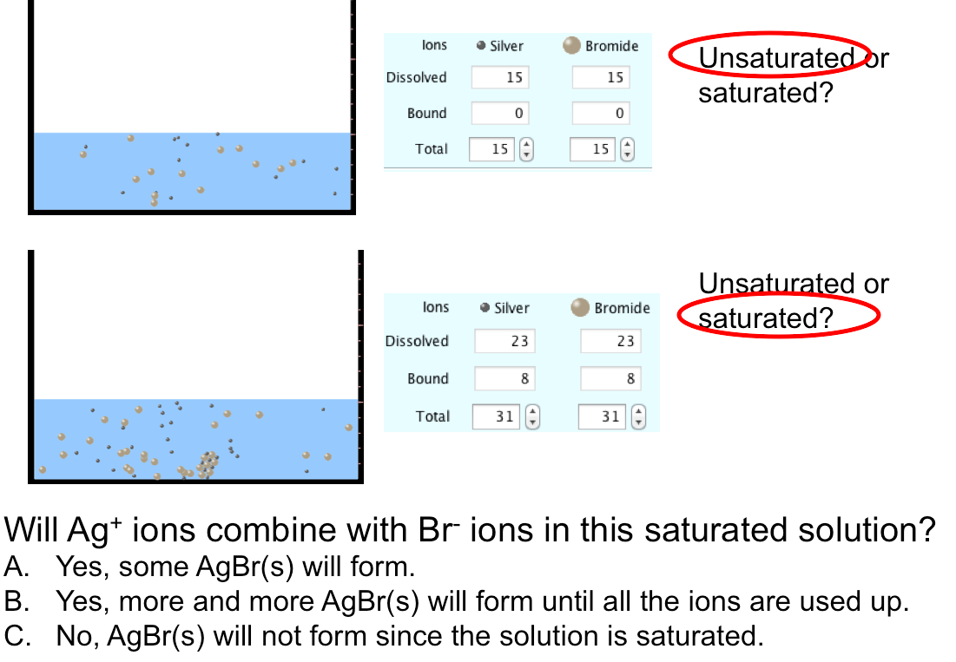
Slide 4: After having used the sim to investigate, check for understanding with questions, polling, etc. The concept of dynamic equilibrium may be introduced; even though solid remains in the saturated solution, dissolution and crystallization continue. The Ag⁺(aq) and Br⁻(aq) ions are forming AgBr(s), but AgBr(s) is also dissolving at the same rate.

Macroscopically, the presence of AgBr(s) in the water (bound ions) indicates a saturated solution.

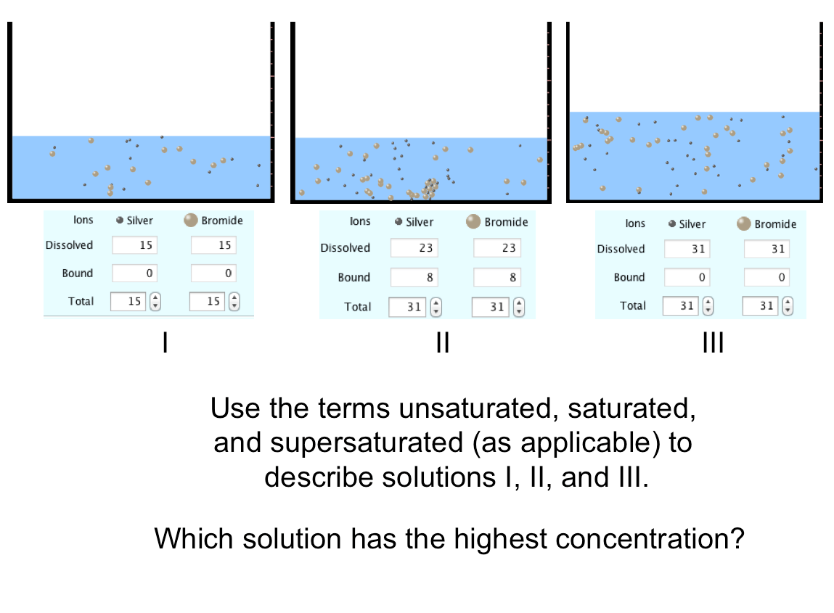
Slide 5: Several topics may be discussed here:
- Solution II is saturated since it still includes bound ions.
- Both I and III are unsaturated solutions.
- Even though II and III have the same total number of ions, with the addition of more water all of the salt in solution III has dissolved.

- Solution II has the highest concentration. Students often think that all of the ions in the container (bound and dissolved) contribute to the concentration. Would a solution with 23 dissolved Ag+ & Br- ions and 18 bound ones have the same concentration as solution II? Yes.

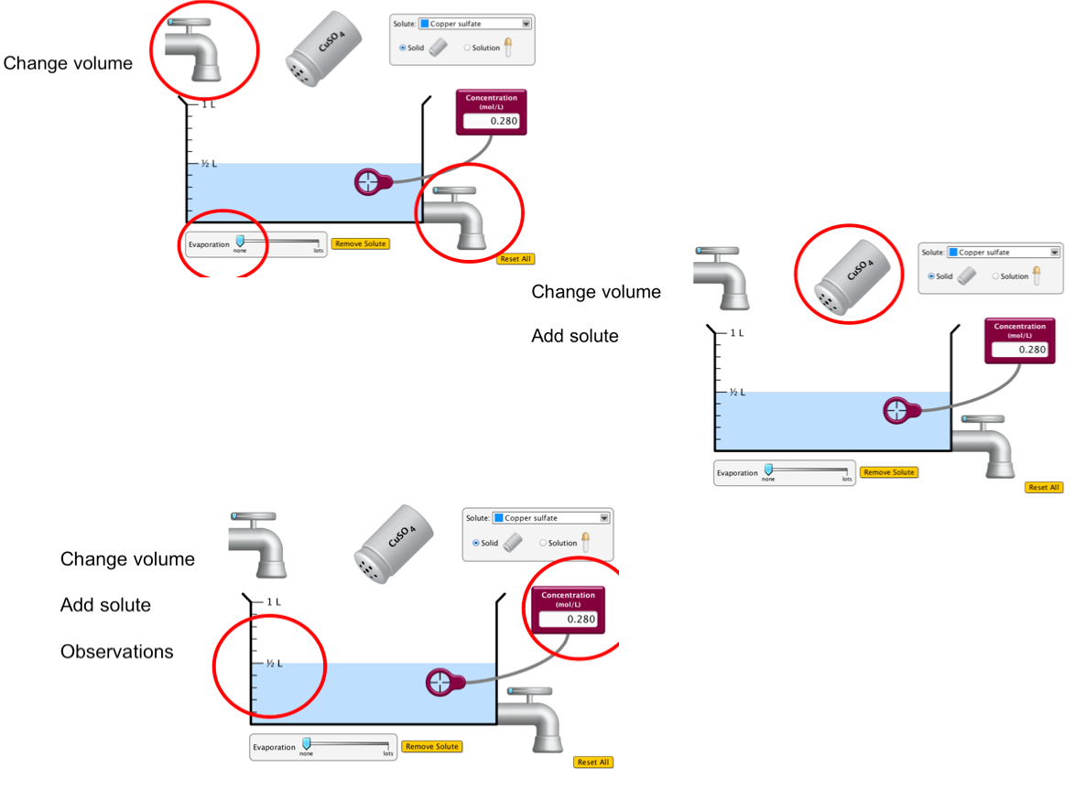
Slide 6: Although particle-level descriptions are important, in the lab chemists are not observing individual ions or atoms. They are making macroscopic observations, like seeing the color of a solution, and using instruments to make measurements.

In the Concentration sim there are different ways to change the volume, add solute, and make observations.

We will use the sim to conduct a few experiments involving unsaturated and saturated solutions.

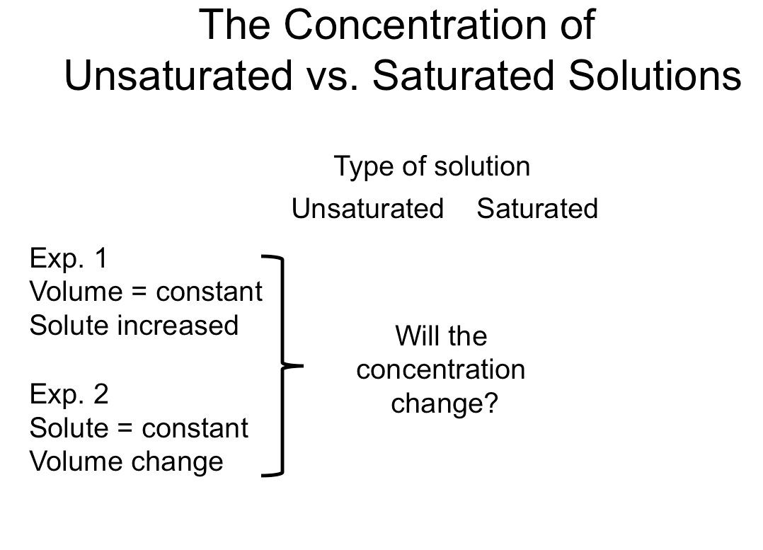
Slide 7: Begin by making a prediction for experiment 1 (constant volume, more solute added). Then, with the sim, begin adding solute. The probe will show an increase in concentration, and the solution will become darker. Eventually, when it becomes saturated, adding more solute no longer increases the concentration.

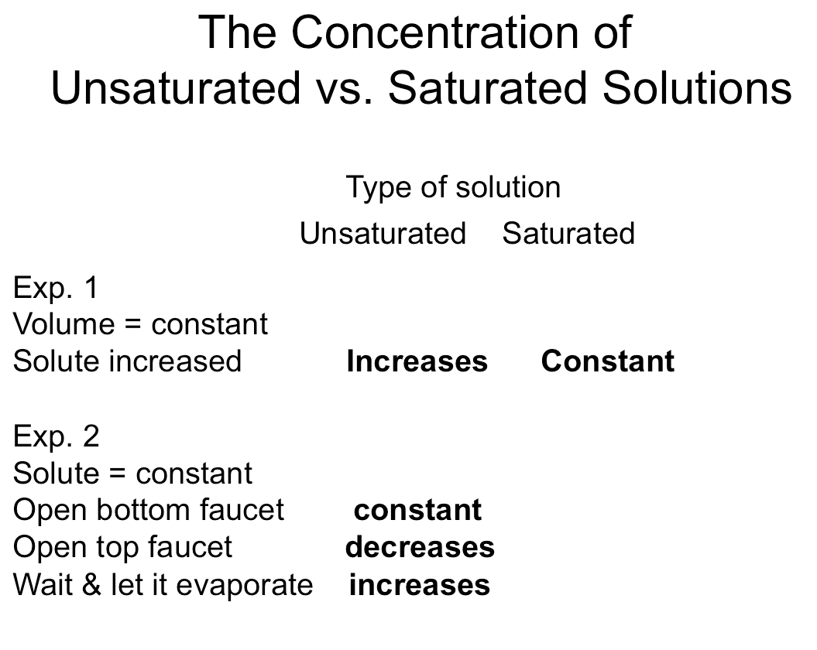
Slide 8: There are several ways to conduct experiment 2 (amount of solute constant, but volume changed). Have the class identify different ways, make predictions, then test with the sim. In each case it is helpful to have students identify what is happening at the particle-level. Post the results for the unsaturated solution, then make predictions and test the saturated solution.

A prevalent misconception here is that as the volume decreases due evaporation the concentration will increase since the ratio of moles of solute/L of solution is increasing. This is paired with the misconception that all of the solute (both dissolved and solid) contribute to the concentration.

The molarity sim may also be used to address this point.

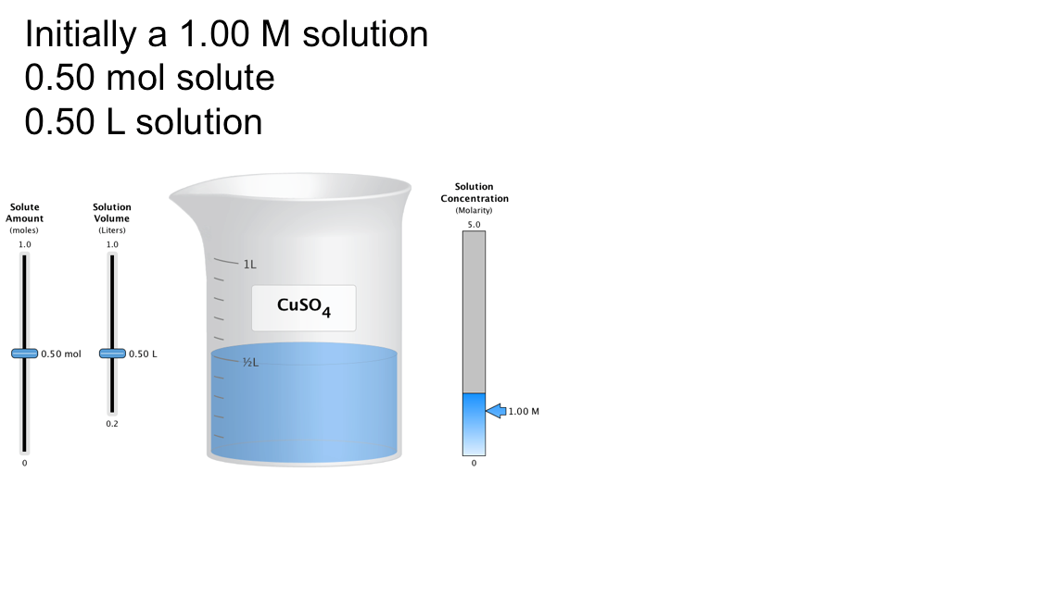
Slide 9: With the molarity sim “prepare” a 1.00 M solution of CuSO₄ by adding 0.50 mol solute to 0.50 L.

Predict what will happen to the concentration if the amount of solute increases, or if the solution’s volume is reduced (evaporation occurs without heating).

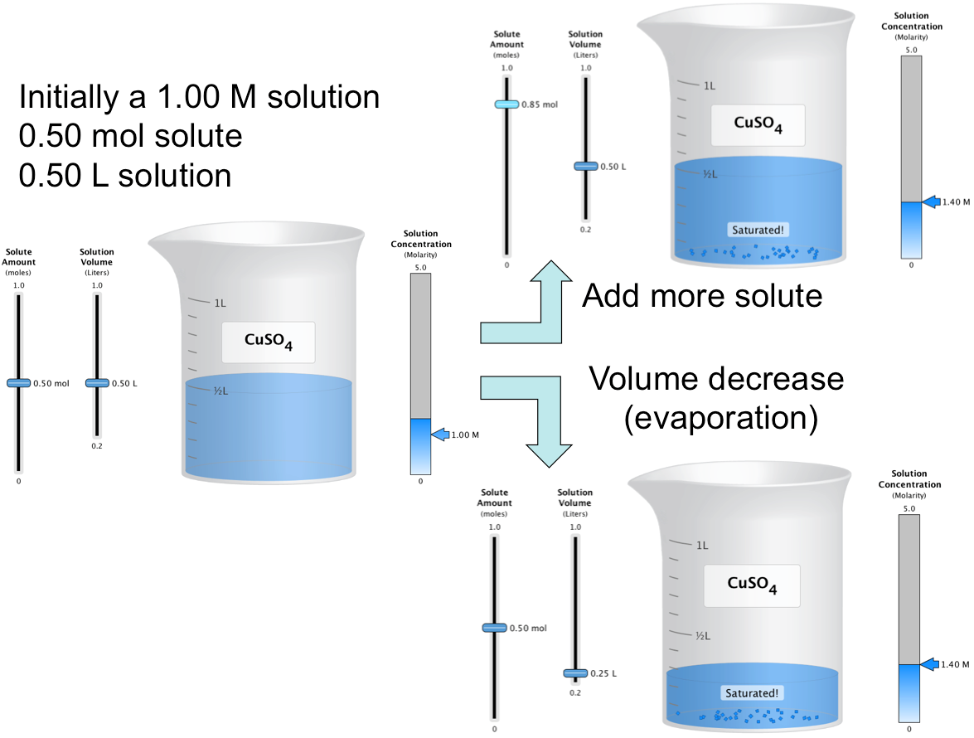
Slide 10: More solute can be added, but the solution will become saturated and the concentration will then no longer increase. Similarly, the volume can be decreased but once again the concentration will reach a maximum.

- The sliding concentration scale (right side of the sim) is very effective at showing the maximum solution concentration for a particular solute.

- It is possible to illustrate that different solutes have different maximum concentrations with this sim.

