Beer’s Law LAB

Open the Beer’s Law Lab simulation on your laptop or tablet:
http://phet.colorado.edu/en/simulation/beers-law-lab

Introduction
- Explore the Beer’s Law screen for a few minutes. Try to figure out what all of the controls show and do.

- How does Concentration affect how much light is absorbed and transmitted through the solution?

Investigating Absorption and Concentration
- Predict what a graph of absorbance versus concentration would look like. Sketch your prediction.
Prediction
Concentration
Absorbance
- Choose a solution from the simulation and measure the Absorbance for different concentrations on the preset wavelength setting.

Data from the Simulation
Concentration ________M Abs | 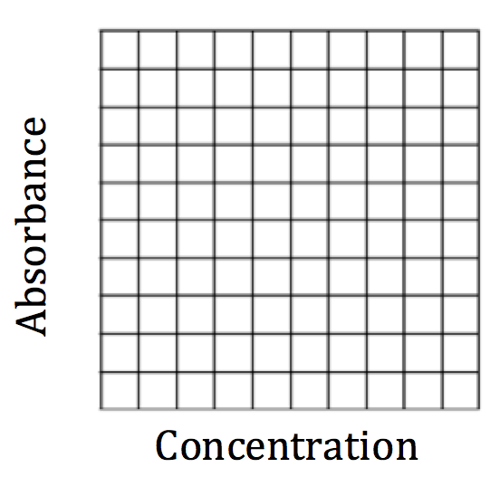

- How does your second graph compare to your prediction?

- Based on Beer’s Law (A = εlC, A = absorbance, ε = molar absorptivity, l = pathlength and C = concentration), do you expect using different wavelengths of light would change the way your previous graph looks? Why or why not?

Investigating Absorption and Wavelength
- a. Compare three solutions of different colors with the same pathlength (width of container).

 |  | Preset Wavelength:  Simulation default setting |  |  | Variable Wavelength:  Set to same color as solution
Solution | Solution Color | Beam Color | Value (nm) | Abs | Beam Color | Value (nm) | Abs

- What combinations give the most absorbance? Why?

- How are beam color, solution color, and absorbance related?

λ(nm) | Abs

- a. Choose a solution and keep concentration and pathlength constant as you graph the absorbance for different wavelengths.

Solution: ____________________________
Absorbance

380 580 780
Wavelength (nm)

- What is the value for the “preset” wavelength for your solution? Mark this point on your graph.

- Why do you think the “preset” wavelength is the best wavelength to use for this solution?

- Compare your absorbance spectrum sketch with a group that chose a different solution. Would you use the same wavelength of light to do spectroscopy experiments with different colored solutions? Why or why not?

- In a lab experiment monitoring the change in concentration of a reddish-brown substance, FeNCS²⁺, a wavelength of 455 nm is used.
  - Does this wavelength agree with your conclusions about beam color, solution color, and absorbance above? Why or why not?

  - What other wavelengths might you consider using for FeNCS²⁺ spectroscopy?

