Energy Forms and Changes

Introduction

In this activity you will investigate the flow of energy in a system. You will observe how energies are transferred and changed as they move along in a system.

1. Click this link: http://phet.colorado.edu/
This is a screen shot of the website:

2. Click the “Play with sims” button.
3. Click “New Sims” -> Click “Energy Forms and Changes”->Click “Run Now!”
4. It will take time to load and then this screen appears:
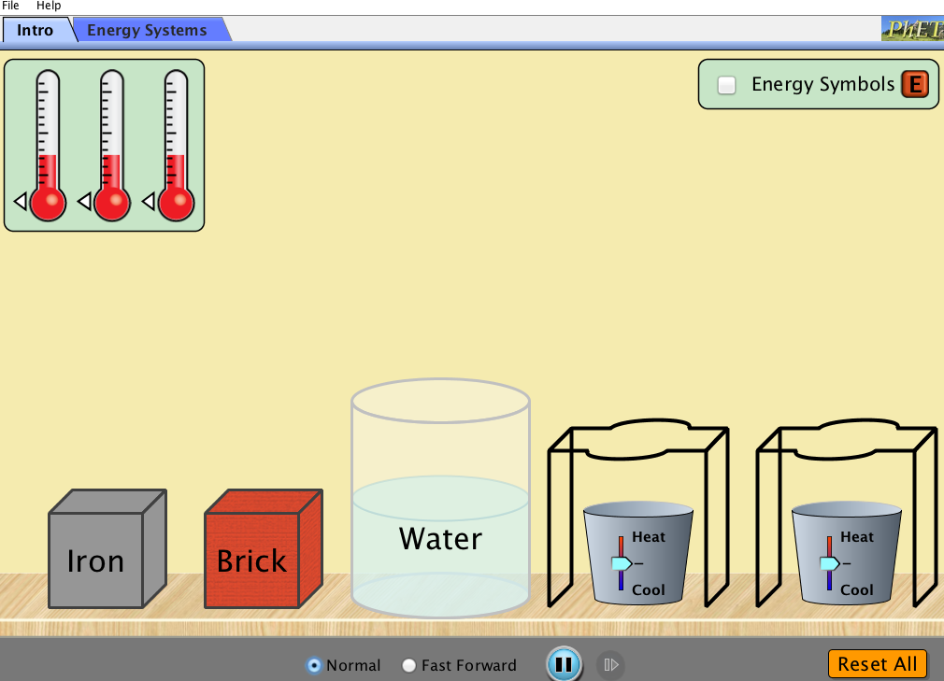

Switch between this document and the sim to complete the activity.

Exploration Phase

Aim: I can analyze how energy changes forms in a system.

1. Click the “Intro” tab on the sim.

2. Explore by placing the iron onto the platform to the right of your screen.

3. Click on “Energy Symbols” on the top right of your screen. Keep this checked at all times to “see” the energy in each object. Energy is the ability to do work. The type of energy we are looking at here is called “thermal” energy.

4. Freely explore by heating or cooling the iron. Use the thermometer to check the temperature of the object.

5. Place a thermometer in the container of water. Notice the temperature of the water.

6. Place the iron back in the container of water. Observe what happens to the temperature of the water. Also, observe what happens to the energy in the water and the object.

Questions

- What does temperature measure? Hint: What happens to the amount of Energy Symbols and the temperature as you heat the object? As you cool the object?

- What happens when you heat the brick and place it into the container of water? Use the word temperature and thermal energy in your response to help describe the energy flow.

- What happens when you cool the brick and place it into the container of water? Use the word temperature and thermal energy in your response to describe the energy flow.

- Place the water container directly onto the platform and heat the water. Starting from the flame, describe the energy flow.

Note: Some energy seems to be “flowing” away from the water container. How might you explain this? Where is the energy going? Is it disappearing?

- Now, cool the water. Starting from the ice cubes, describe the energy flow.

Explanation Phase

5) Create a rule that describes how energy is transferred from one object to another in a system.

Click on the “Energy Systems” tab and make the screen look like this:

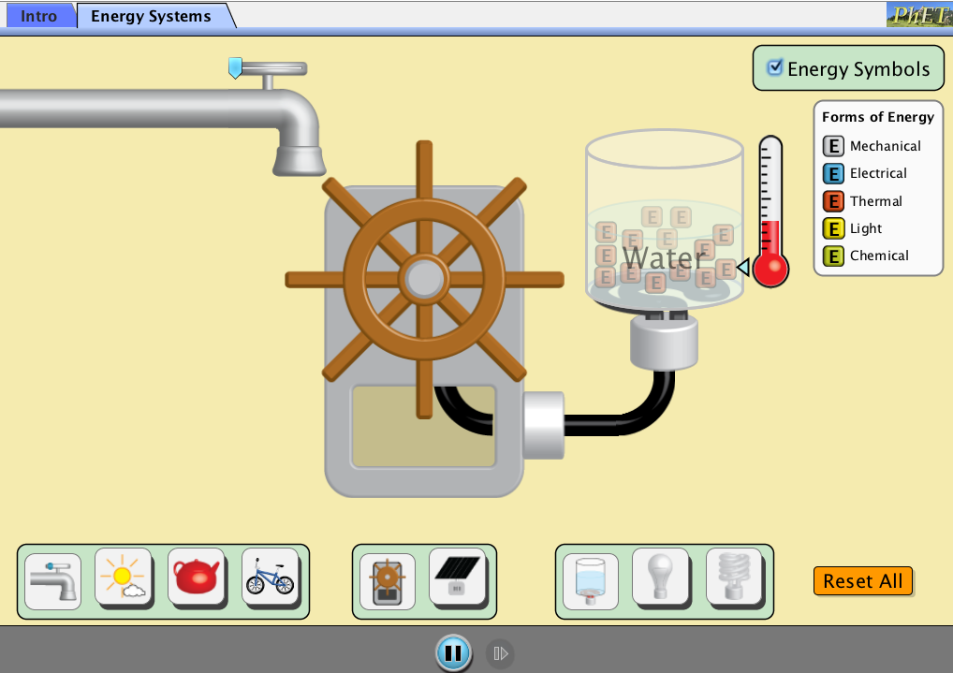

6) List the different forms of energy that are represented in this simulation:

7) Turn the faucet all the way on by moving the blue arrow to the right. The water should move the turbine or generator. This should in turn direct energy to the receiver, the container of water. Describe the energy flow in this system.

The water from the faucet produces _________ energy. This turns the turbine, which creates ____________ energy. This _______________ energy causes the water to ___________, creating ___________ energy as an output.

Concept: This is a description of energy flow or transfer, the exchange of energy between objects in a system. In this exchange, energy can take different forms.

8) Complete the table below based on the given parts to explore how energy is transferred within different systems.

Energy Source | Generator | Receiver | Description of Energy Transfer
Faucet | 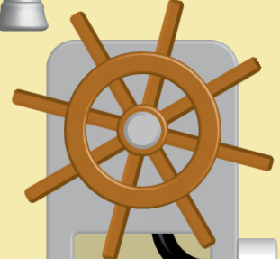 | 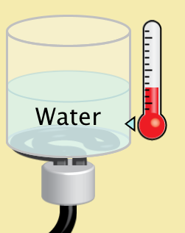 | The water from the faucet produces ______________________ energy. This turns the turbine, which creates _________________ energy. This _______________ energy causes the water to ___________, creating ______________ energy as an output.
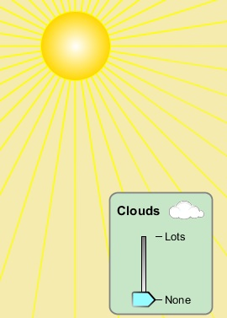  Solar Energy | 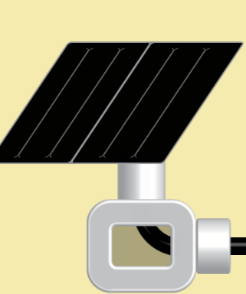 | 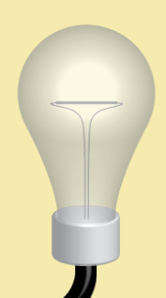 | The ______ produces ___________ energy. This is absorbed by the solar panel, which creates _________________ energy. This _______________ energy causes the light bulb to light up, creating ______________ energy as an output.
Tea Kettle Steam  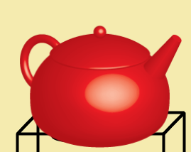 |  |  | The ___________ produces ___________ energy. This turns the turbine, which creates _________________ energy. This _______________ energy causes the water to ____________, creating ______________ energy as an output.
Cyclist  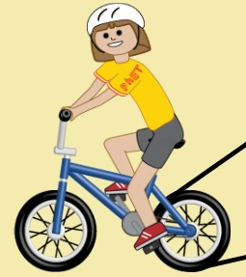 |  |  | The __________ produces ___________ energy. This turns the turbine, which creates _________________ energy. This _______________ energy causes the light bulb to light up, creating ______________ energy as an output.

9) Why does the cyclist need to be fed?

10) Return to the solar panel system. What happens when you increase the amount of clouds?

Application Phase

11) Using what we’ve learned form this sim, determine what type of energy is shown in each row.

Type of Energy:
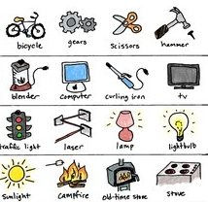

a)

__________________________________

b)

__________________________________

c)

___________________________________

d)

____________________________________

12) Take a look at the picture below. Explain the transfer of energy you see in this system.
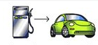

________________________ _______________________

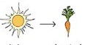

______________________ _______________________

Conclusions: Scientists say that “energy cannot be created or destroyed.” What does this mean to you? Share your thoughts with your partner.

Finished: Congratulations! You’ve got the power (energy!)

