Color Vision

Introductions
In this activity, you will investigate what color a person sees from various combinations of blue, green, and red light.

1. Click this link: http://phet.colorado.edu/
2. This is a screenshot of the website:

2. Click the “Play with sims” button.
3. Click “By Grade Level” -> Click “Elementary School” -> Click “Color Vision”->Click “Run Now!”
4. It will take time to load and then this screen appears:

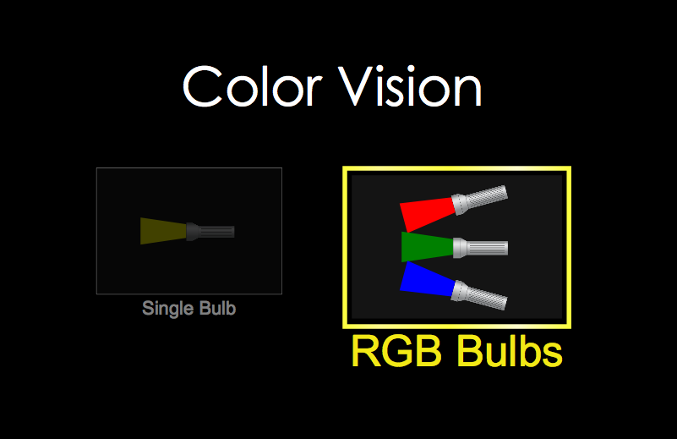

5. Click “RGB Bulbs” and then this screen appears:

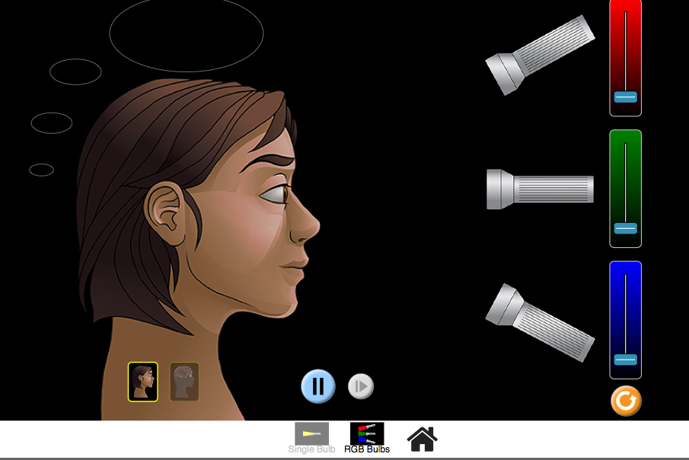

Switch between this document and the sim to complete the activity.

Exploration Phase

- Freely explore different combinations of color.
- Experiment applying different amounts of colors and combinations.

Questions

- What does the person see when one color is raised to the maximum level?
(The other colors should not be applied.)

- What does the person see when all three colors are raised to their maximum levels?

3. What does the person see when no color is applied?

Explanation Phase

Aim: Create a rule that explains what happens when a person sees all three colors at their maximum levels at the same time. Describe the rule here and have it checked by the teacher.

Apply all three colors at their maximum levels to make the screen look like this:

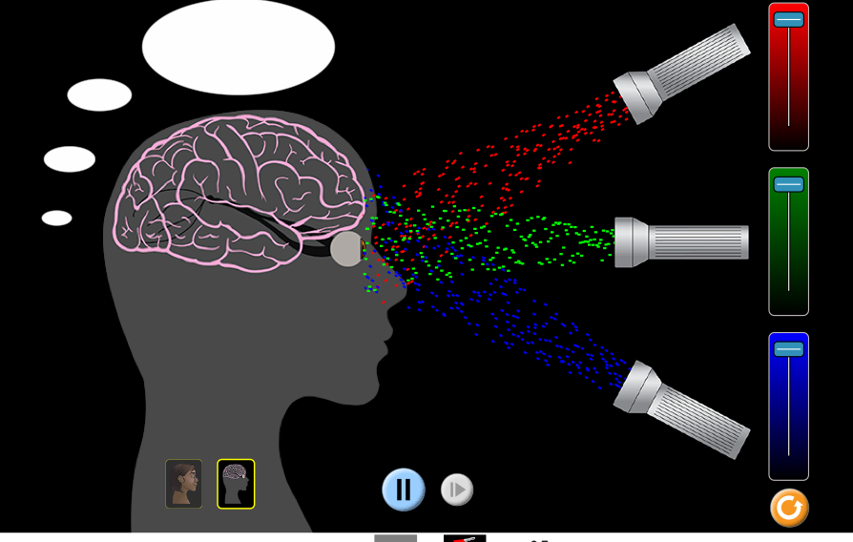

Here are some concepts:
Red, green and blue are primary colors of light. When mixed together at the right intensity, they create white light.

The absence of color is called “black”.

Use the sim and the following table to record what the person sees under a variety of conditions.
*Be as descriptive as possible when describing what color light is visible.

Red | Green | Blue | Visible Light
Min | Min | Max
Max | Max | Max
Min | Min | Min

Come up with a rule that explains what happens when different amounts of light are applied.

Write here:

Application Phase
One concept that we learned is that the addition of primary colors of light can produce a wide range of other colors. Use your knowledge of color combinations and determine what primary colors, when combined with the correct color and amount, create secondary colors of light.

Fill in the missing parts of the chart below.

Red | Green | Blue | Visible Light
Min |  | Max | cyan
 | Max |  | Yellow
 |  |  | magenta

Conclusion:
Compare the data from different levels and explain how secondary colors of light are created.
Concept:
Complimentary colors = secondary + primary = white

*Challenge:

How is white light created?
Is white light a color? Explain why or why not.

Congratulations! You are now an expert on ROYGBIV!

For additional information or for a breakdown of science concepts, check out:
http://www.physicsclassroom.com/class/light/Lesson-2/Color-Addition

