Title: Forces and Motion: Basics
Introductions
In this activity you will explore how force, when applied, can impact the direction in which an object can move and the sum(s) of these forces.

- Click this link to get to the activity: http://phet.colorado.edu/en/simulation/forces-and-motion-basics

This is a screen shot of what you will see once you click the link:

- Click the “Run Now” to begin the activity. (You may have to download a free version of Java to play the game)

Use your explorations from the “Forces and Motion: Basic” activity to record your observations and answer the questions below.

Exploration Phase

1. Begin your explorations by first playing the “Tug of War” portion of the activity. Below is a screen shot of the activity.
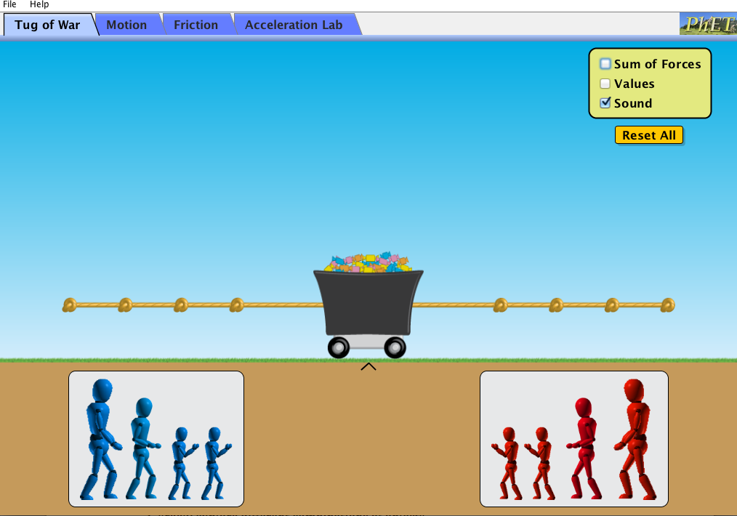

- Place both the red and blue people on the rope.

- Explore what happens when the red people pull on the rope.

- Explore what happens when the blue people pull on the rope.

- Explore what happens when you put various amounts of red and blue people on each side of the rope.

- Click “Reset”, which is located in the upper right hand corner of the screen. Below is a screen shot of where you can find the “Reset” button.

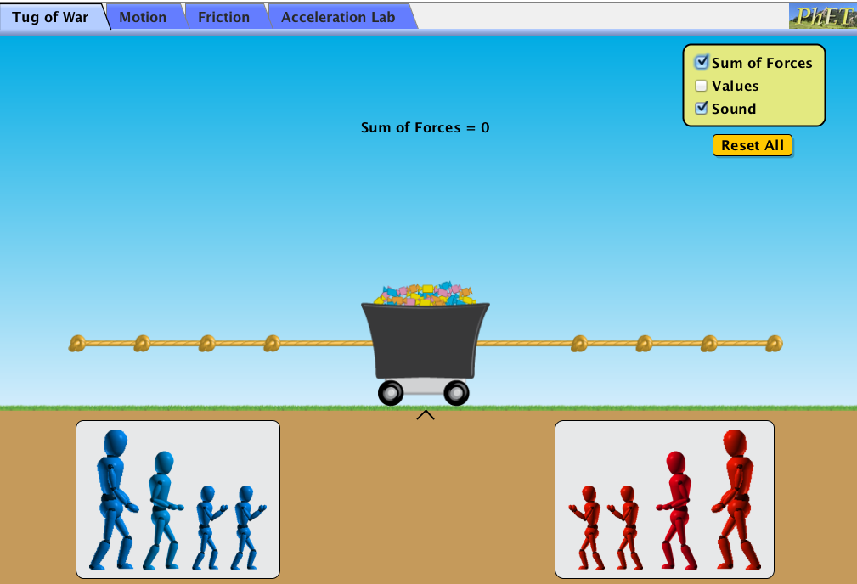
- After clicking “Reset”, click “Sum of Forces”. Continue to explore what happens when you place various amounts of red and blue people on each side of the rope.

- Click “Reset” again.

- Click “Sum of Forces” and “Values”. Continue to explore what happens when you place various amounts of red and blue people on each side the rope.
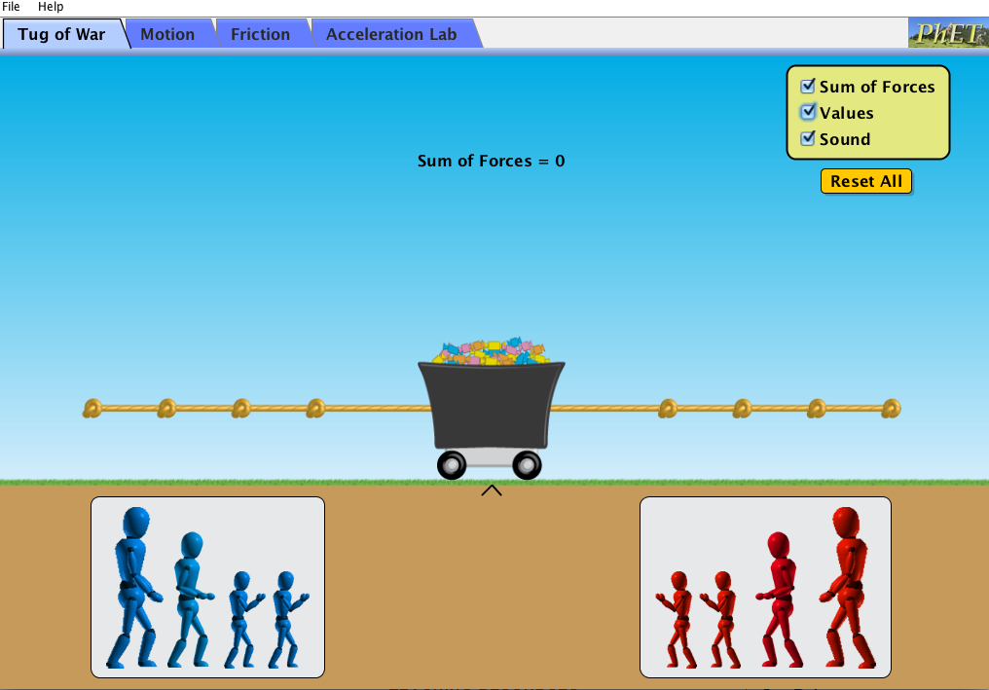

Questions

- Which way do the red people pull on the rope?

- Which way do the blue people pull on the rope?

- What happens when you have people on one side of the rope but not on the other side?

- What happens when they’re an equal amount of people on each side of the rope?

- What happens when there are no people on either side of the rope?

- Does 1 small blue person pull the same amount of force as 1 small red person? How about 1 medium red person? How about 1 large red person?

- Is possible for each side of the rope to have an equal amount of force being pulled with people of different sizes? Provide an example from this activity of how this can occur.

- Is it possible for each side of the rope to have an equal amount of force being pulled with different amounts of red and blue people? (Example: Can there an equal amount of forced being pulled on the rope with 1 red person 2 blue people?) Provide an example from this activity of how this can occur.

- Did the position of where you placed each person on the rope impact the amount of force that was being pulled? Provide an example to demonstrate why or why not.

- As you explored the Sim, you noticed that there are different sizes of both red and blue people. You also noticed that the size of the person determined how much force they were able to exert when pulling the rope. Fill in the table below to compare how much each person can pull.

Size of People | Amount of Force
1 small
red person
1 small
blue person
2 small
red people
2 small
blue people
1 medium
red person
1 medium
blue person
1 large
red person
1 large
blue person

Using the chart you completed above or the Sim activity, answer the following questions.

- Can 2 small red people pull the same amount as 2 small blue people? Explain why or why not?

- Can 1 medium blue person pull the same amount at 2 small red people? Explain why or why not?

- Can 1 large person pull the same amount as 1 small person? Why or why not?

- Can 2 small people and 1 medium person pull the same amount as 1 medium person and 1 large person?

Explanation Phase

In this activity you have discovered that force is measured in Newton’s (N). You have also observed that the Net Force, which is also known as the “Sum of Forces”, occurs when there are multiple forces on an object. Based on this knowledge, you will create an “Aim”, complete a data tables, and answer the following questions that are listed below.

Aim: Create rule that describes how to demonstrate an equal amount of force being applied to each side of the rope.

Describe the rule here (and have it checked by the instructor):

Use the Sim and fill in the blanks of the following table. This table will allow you to show all the different combinations of how force is applied to each side of the rope.
Amount of  Blue People | Amount of Force on  Left Side in (N) | Amount of Red People | Amount of Force on Right Side in (N) | Which side had more force, the right, left, or was it equal? | What is the sum of the forces in (N)?
4 |  | 0
0 |  | 1
 | 150N |  |  | Left | 50N
3 |  | 3 |  | Right
 |  |  |  | Equal | 0N
 | 250N |  | 200N
2 |  | 2 |  | Right
3 |  | 2 |  |  | 0N

- Does there need to be an equal amount of people on each side of the rope in order to have equal forces?

- Why would one side have a greater amount of force?

- How can one side have more force even though there is an equal amount of people on each side?

- How can one side have more force even though there is not an equal amount of people on each side?

- What is required for each side to have equal sum of forces?

Use your rule to answer the following question. Follow these steps to help you answer the question.

Step 1: There are 2 blue people on the left side of the rope and 2 people of the right side of a rope.

Step 2: The sum of the forces is 100N.

Step 3: There is more force being applied to the right side of the rope.

Question: How can we make the sum of the forces equal to be 0N with an equal number of people of each side of the rope? Write and show your work below.

Application Phase

Now that you know how to make the sum of the forces equal, can you list all of the different combinations that show equal forces being applied? List all your combinations below.

Example: 2 small red people and 2 small blue people equal 0N.

