Investigating the pH level of the 11 different basic substances

OBJECTIVES:
Through the use of simulation found in https://phet.colorado.edu/sims/html/ph-scale-basics/latest/ph-scale-basics_en.html;
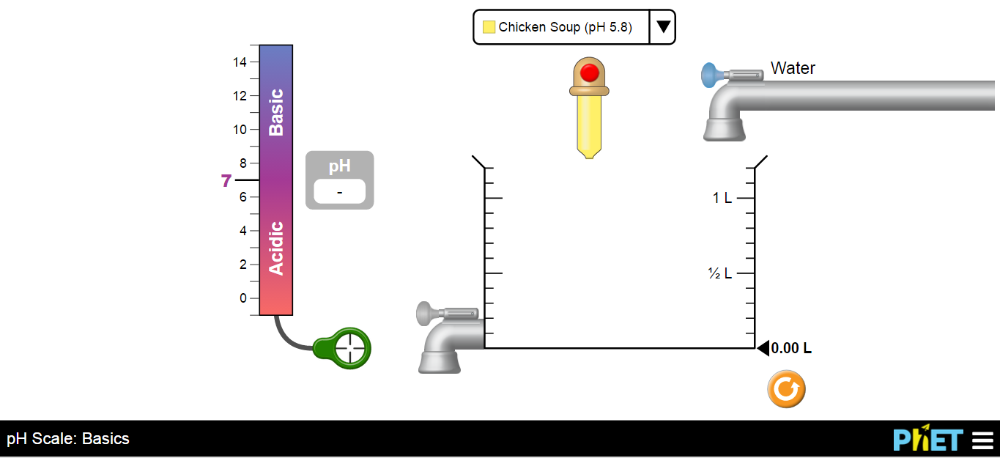
- Students will be able to know each pH level of the 11 different given basic substances;
- To be able to know how dilution affects the pH level of the given substances;
INTRODUCTION:
The pH is a measure of hydrogen ion concentration. In order to measure the acidity or alkalinity of a solution, the pH scale is a usable indicator which helps to distinguish whether a substance is an acid or a base. Its scale ranges from 0-14. A pH that is 7, is neutral. 7 below is acidic while 7 above is basic.
In this activity, by the use of the pH indicator you will have to know the pH level of the given substances and how the addition of water to these substances can affect the acidity or basicity of its pH level.

INSTRUCTION:
In order to make and complete this activity, you will have to access to this site; https://phet.colorado.edu/sims/html/ph-scale-basics/latest/ph-scale-basics_en.html. The illustration that was shown above is the exact simulation that you are going to use until the end of this activity.
- Click the drop-down lists of the substances and press the red button up to the desired volume of substance to be used.
- You can also add water by clicking the blue button (upper right) or drain some content in the cylinder by pressing the blue button (lower left) of the drainer.
- In order to know the pH level of the substances, drag the pH indicator up to the liquid content inside the cylinder.
- Always empty the cylinder whenever you want to determine another pH level of a substance.
- To learn more, go and explore through this simulation.

PROCEDURE:
- There are 11 substances in the drop-down list in the simulation, know and record in the table the different pH level of each substances and determine whether it is an acid or a base by putting a check mark() into it.
Table I. Identification of the pH level of the substance and determination whether the substance is an acid or a base.
Name of substance used | pH level | Acid | Base
Milk
Coffee
Soda pop
Vomit
Drain cleaner
Battery Acid
Orange juice
Chicken soup
Blood
Hand soap
Spit

- The volume of substance and the water to be used was given in the table below. Use the pH indicator in the simulation to determine the pH of the substances with a pure water added into it.
Table II.
Name of Substance | 0.10L of substance  0.15L of water | 0.15L of substance  0.10L of water | 0.15L of substance  0.30L of water | Acid or Base?
Drain Cleaner
Hand Soap
Blood
Spit
Milk
Chicken Soup
Coffee
Orange juice
Soda pop
Vomit
Battery Acid

CONCLUSION:
- Based on the information that you supplied in the Table I. What substance has the most acidic level of pH? The most basic? How can you say so?

- What is the pH scale of pure water?

- How can you explain that even though you continue to add pure water into a substance, even though the resultant pH might differ a little, the acidity or alkalinity of substance still remains the same to that of substance?

- When pure water is added to an acid substance, will the pH of the substance increase or decrease?

- When pure water is added to a base substance, will the pH of the substance increase or decrease?

- Why is acid always added to water and not the reverse?

