Name______________________________________________________Date___________Period________
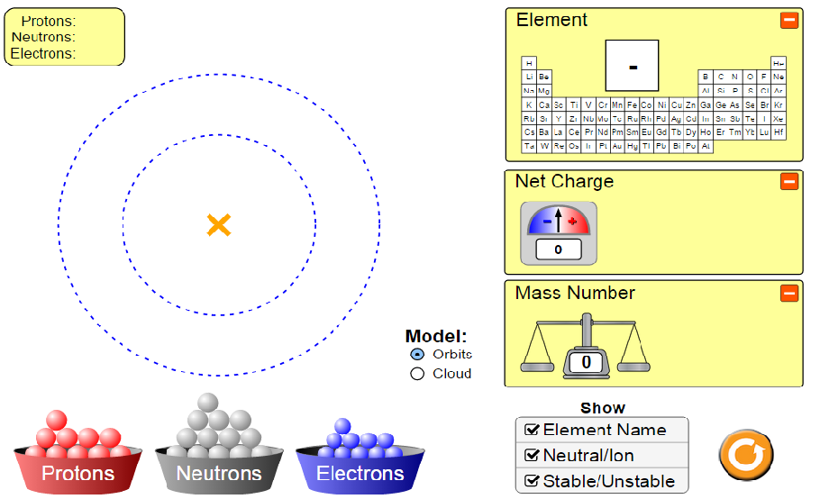
https://phet.colorado.edu/sims/html/build-an-atom/latest/build-an-atom_en.html
For use with HTML 5 (Chromebooks or Tablets)
Build An Atom WebLab PhET
Choose <ATOM> Set up your options with check marks to show: orbits, element name, neutral/ion and stable/unstable

Part 1: Investigating Elements Names
Procedure:
1. Build an atom with 1 proton and 1 electron and fill in the chart below
2. Build an atom with 1 protons and 0 electrons and fill in the chart below
3. Build an atom with 1 protons and 2 electrons and fill in the chart below
4. If the name of your element did not change, try adding different types of particles until your get a new element. Notice how its mass is different from Hydrogen’s mass.

 | Element Symbol | #Protons | #Neutrons | #Electrons | Net Charge | -ion, +ion or neutral | (S)table or (U)nstable | Mass Number
1 | H
2
3

Questions:
- In trials #1-3, did changing the number of electrons change the name of the element? If not, what did it change?

- What particle must you change in order to change the name of the element?

- How is mass affected when you add protons?

Part 2: Investigating Mass
Procedure:
1. Create neutral & stable hydrogen with a mass of 2. Fill in the chart below
2. Create neutral & stable helium with one neutron a mass of 3. Fill in the chart below
3. Add one neutron to the helium. Fill in the chart below
4. Create neutral & stable lithium with 3 neutrons. Fill in the chart below
5. Add one neutron to the lithium. Fill in the chart below
6. Vary the number of electrons and notice any change in mass
7. Vary the number of protons and notice any change in mass

 | Element Symbol | #Protons | #Neutrons | #Electrons | Net Charge | -ion, +ion or neutral | (S)table or (U)nstable | Mass Number
1 | H
2 | He
3 | He
4 | Li
5 | Li

Questions:
- To go from Hydrogen (Trial #1) to Helium (Trial #2) to Lithium (Trial #4), what particle did you have to change?

- When you changed this particle, what was the effect on the mass of the atom? (Be specific)

- When you increased the number of neutrons by one in Trials #3 & #5, what happens to the mass number?

- What is the likely mass of a single proton? _______________ neutron? _________________

- Does adding or removing extra electrons have any effect on the mass? Explain why or why not:

6. Different elements can have the same mass. Show sample data below to prove it
(they may be unstable)
 | Element Symbol | #Protons | #Neutrons | #Electrons | Net Charge | -ion, +ion or neutral | (S)table or (U)nstable | Mass Number
1
2

Part 3: Investigating Charge
1. Before you begin - Define the scientific or mathematical meaning of:
- Ion b. Net c. Charge
2. Complete the sentence using the terms above: When a neutral atom gains or loses electrons, it is called a(n) ________________ and it’s __________________ ______________________ DOES NOT equal zero.

Procedure:
- Create neutral & stable hydrogen with a mass of 1 (no neutrons). Fill in the chart below
- Add one extra electron to the hydrogen. Fill in the chart below
- Take away two electrons (you now have 0 electrons). Fill in the chart below
- Try combinations of protons, neutrons and electrons until you discover the secret to creating a neutral atom every time.
 | Element Symbol | #Protons | #Neutrons | #Electrons | Net Charge | -ion, +ion or neutral | (S)table or (U)nstable | Mass Number
1 | H |  | 0 |  |  |  |  | 1
2 | H
3 | H |  |  | 0
Questions:
- To create a neutral atom, what must be true about
a. The protons? b. The electrons? c. The net charge?
To create a (+) ion, what must be true about
a. The protons? b. The electrons? c. The net charge?
- To create a (-) ion, what must be true about
a. The protons? b. The electrons? c. The net charge?

Part 4: Investigating Stability of Isotopes
For the nucleus to stay together, it must have neutrally charged particle. The neutral particles separate protons from each other and from electrons. An unstable nucleus will break apart into more stable pieces, dividing the nucleus into parts. This process is known as radioactive decay. In this part, you will be building different isotopes for the same element which may or may not be unstable. Before you begin, look up the scientific meaning of:
- isotope b. radioactivity c. nucleus

Procedure:
1. Create the heaviest, largest stable, neutral atom possible! Fill in the chart
2. Make the same atom UNSTABLE by removing 3 particles without changing the number of protons. Fill in the chart
3. Return to your heaviest, largest stable neutral atom. Now, try making it unstable by adding particle(s) without changing the number of protons. Fill in the chart

 | Element Symbol | #Protons | #Neutrons | #Electrons | Net Charge | -ion, +ion or neutral | (S)table or (U)nstable | Mass Number
1
2
3
Questions:
1. What particle did you add or remove to change the atom from stable to unstable?

2. Is the mass of the stable atom the same as the mass of the unstable atom? Explain

3. NUCLEUS or ORBITS What part of the atom is affected by the addition or removal of neutrons? (Circle one)
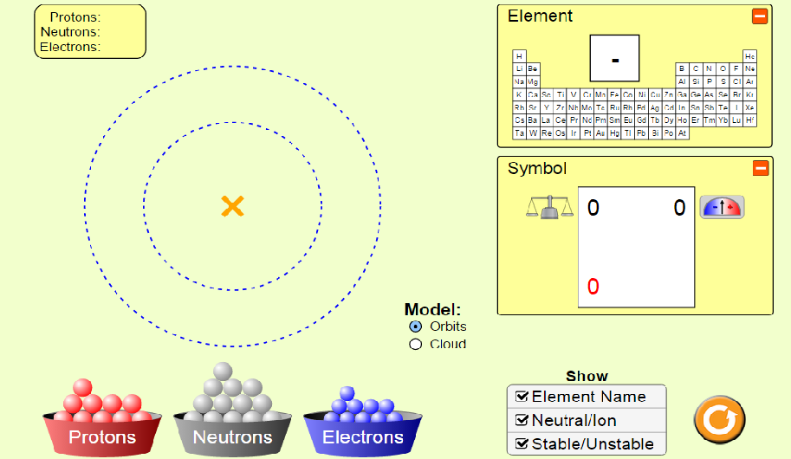
Choose <SYMBOL> Set up your options with check marks to show: orbits, element name, neutral/ion and stable/unstable
The nuclear symbol is a short cut method of showing some of the things you’ve investigated so far.
- Build a Fluorine atom that is neutral and stable
- Play around with adding and removing neutrons and notice how the top left number changes
- Play around with adding and removing electrons and notice how the top right number changes.
- Add and remove protons and notice all the changes to the symbol
- On the sample below, explain what each number represents:
If time allows: Choose <Game> and play each of the games

