Name________________________________________________Date___________Period________
Acid Bases WebLab PhET Chromebook Version
https://phet.colorado.edu/en/simulation/acid-base-solutions Click <Introduction> to begin.
Part 1: Procedure
1. The lab has 2 tools that allow you to test for pH values: A probe , and pH paper 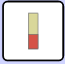. Use each one by dipping it into the solution to be tested. Try all the given types of solutions and fill in the Data Chart with the pH value 0-14.
2. The circuit with a battery and bulb as shown: is the tool used to test for conduction of a solution. By dipping the wire leads into the solution, the bulb with either remain unlit, be dimly lit, be somewhat bright or very bright. Test each solution and record your observation for the bulbs brightness in the chart below.

Part 1: Data | pH Value from Probe | Color & pH Value from pH Paper | Observations from Circuit Tool  Describe the brightness
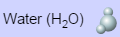

Part 1: Analysis
1. What pH value range is observed: a. for acids?______________b. for bases?____________

2. Why are some solutions better conductors of electricity?

Part 2 Procedure, Data & Analysis:
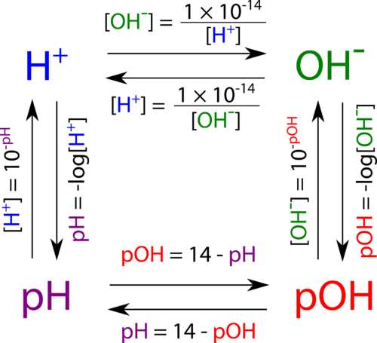
Recall: The amount of ionization or dissociation of ions determines the strength of an acid or base. The concentration of [H₃O⁺], hydronium and [OH⁻], hydroxide ions can be used to calculate pH and pOH as shown on the diagram here:
Note: we use [H₃O⁺] and [H⁺] interchangeably.

- Click on Water Solution, Graph View, Probe Tool. Insert the probe in the water. Notice that the initial concentration of the solution is given before any ionization or dissociation takes place.
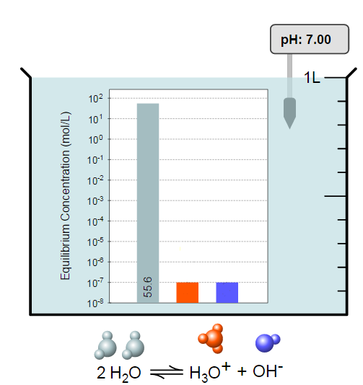
- Fill in the missing concentration values for the hydronium and hydroxide ions on the diagram here: Use the concentration value for [H₃O⍅] to calculate the pH. Show work:

3. Use the concentration value for [OH⁻] to calculate the pOH. Show work:

4. Did your answer to #2 match the pH given in the simulation? _________________________
5. Is the answer to #3 equal to: (14 - pH)? ___________ Show work: _____________________
6. Is the solution an acid, a base or neutral based upon the calculated pH?_________________

HONORS ONLY: Attach notebook paper to show calculations for the pH and pOH for the other solutions.

Part 3 Procedure, Analysis, Conclusion: My Solution
Across the bottom of the screen, click the button. The default setting shows a weak acid with a concentration of 0.010 M. Insert the pH probe to show an initial pH of 4.50. The beaker is shown below:
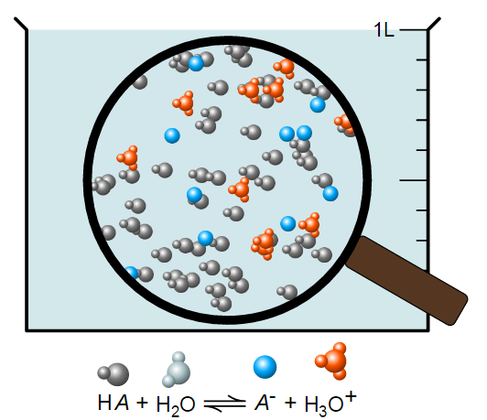
1. Slide the initial concentration bar to the right to increase the number of solute molecules and then slide it to the left.
What effect does changing the concentration have on the pH value? (Be specific)

2. Return to your default setting and insert the probe. Now slide the strength to the right to make the acid stronger.
- As you increase the strength, describe the change in the number of blue A⁻ ions, orange H₃O⍅ ions and the original HA acid:

- As you increase the strength, describe the change in the concentrations of the ions in the solution? Hint: Click <Graph> to see how the concentrations rise and fall.
3. Yes or No? Does the pH seem to depend upon the concentration of [H₃O⁺] ions?

4. We always assume that strong acids will 100% ionize in water. Click reset and move the slider to strength: strong. Insert the probe. Record pH. Observe the number of ions in the beaker and click <Graph> to observe the concentrations.
- pH Value = ______________
- YES or NO? Does the beaker contain particles that have not ionized and have 0% concentration? If so, what particle seems missing? ____________________. Why is it likely missing?

5. Click reset and change to a base. Repeat #1-4 above and describe any different results or simply write, “Same results for bases.”
#1:
#2:
#3:
#4:

Conclusions: If the answer is no, explain why not.
6. YES or NO? Can a weak acid be concentrated?

7. YES or NO? Can a strong acid be dilute?

8. YES or NO? For acids, can increasing the initial concentration increase the pH?

9. YES or NO? For Bases, can increasing the initial concentration increase the pH?

Extension: In <My Solution>, try different combinations of initial concentration and strength. Dip probe, click <Graph> to record ion concentration. Use concentration to calculate pH and verify probe data.

