Name: _____________________________ Period: _______ Date: __________________
Directions: Open the Charges and Fields simulation https://goo.gl/qkVq06 Then, answer the questions below using evidence from your observations and the data you collect. Voltage is the difference in electrical charge between two points in a circuit (expressed in volts).
- Check all the boxes as shown
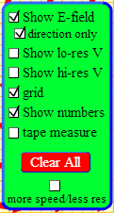
What do you observe about the electric field (E – field – small red arrows with tiny holes in them) when you place two “like” charges (positive and positive OR negative and negative) 2 meters apart? Record the voltage.

- Change the distance between your “like” charges to ½ meter. How did this affect your electric field? Record the voltage.

- Now, PRESS clear all in your green box. Place two opposite charges 2 meters apart. How does this affect your electric field? Record the voltage.

- Next, move your opposite charges within a ½ meter from one another and record your observations. How does this affect your electric field? Record the voltage.

- Place an electric field sensor (orange sphere) a ½ meter from a positive charge, and then slowly move it further from the charge (up to 2 meters away). What do you notice about the size of the arrow, which represents electric force?

- CONCLUSIONS: Which charged particles repelled each other? Which charged particles were attracted to each other? What caused the electric force to increase and decrease (size of arrow given off by the E-Field sensor – orange spheres)?

Directions: Open the Faraday’s Law 1.1.2 simulation: https://goo.gl/gz5Nmw Then, answer the questions below using evidence from your observations.
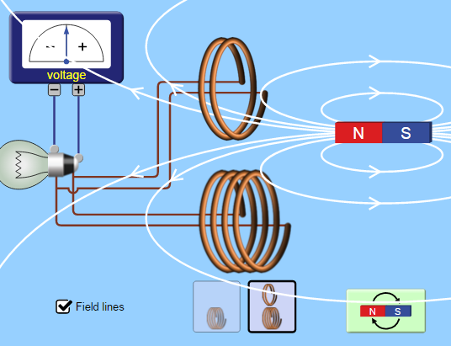
BE SURE TO SELECT THIS OPTION TO VIEW LESS AND MORE COILS OF WIRE.
- First, slowly move the magnet into the shorter coil of wire (the coil near the top). What happens to the voltage when the magnetic field lines that are closer together (at the North and South Poles) move through the wire, compared to when the middle of the magnet moves through the coil?
________________________________________________________________________________________________________________________________________________________________________________________________________________________________________________________________________________.
- Next, move the same magnet through the longer coil of wire (the coil near the bottom). Move the magnet the same as before. Do you notice any differences in voltage? Why or why not?
________________________________________________________________________________________________________________________________________________________________________________________________________________________________________________________________________________.
- Flip the battery and repeat the procedures above, do you notice any differences? Why or why not?

______________________________________________________________________________________________________________________________________________________________________________________.
- Does the speed at which you move the magnet inside of the coils have any effect on voltage? Support your observations with evidence from the simulation.
______________________________________________________________________________________________________________________________________________________________________________________.
CONLCUSION: ON A SEPARATE SHEET OF PAPER, DESCRIBE WHAT YOU LEARNED ABOUT THE RELATIONSHIP BETWEEN MAGNETISM AND ELECTRICITY. USE EVIDENCE YOU GATHERED DURING BOTH SIMULATIONS TO SUPPORT YOUR ANSWER.

