Trig Tour - Using Reference Angles with a Unit Circle
PRE-PLANNING | PRIOR KNOWLEDGE
- Know the trigonometric functions of Sine, Cosine and Tangent
- Know how a unit circle is constructed
- Graph on a Cartesian coordinate system
 | LEARNING GOALS
- Associate the coordinates of points on the circumference of the unit circle with the cos and sin of the angle made by the radius containing these points, with the positive direction of the x-axis
- Deduce the sign (+, -, 0) of trig function for any given angle without a calculator using the unit circle concept.
- Find values of sin, cos and tan of negative angles and of angles >360° from the unit circle
- Define exact trig functions for special angles using degrees or radians for angle measures.
 | Common Core Standards | Common Core Practices
 | CCSS.Math.Content.HSF.TF.A.3  (+) Use special triangles to determine geometrically the values of sine, cosine, tangent for π/3, π/4 and π/6, and use the unit circle to express the values of sine, cosine, and tangent for x, π + x, and 2π - x in terms of their values for x, where x is any real number.  CCSS.Math.Content.HSF.TF.A.2  Explain how the unit circle in the coordinate plane enables the extension of trigonometric functions to all real numbers, interpreted as radian measures of angles traversed counterclockwise around the unit circle. | 2. Reason abstractly and quantitatively  7. Look for and make use of structure
 | MATERIALS
PhET Trig Tour simulation: http://phet.colorado.edu/sims/html/trig-tour/latest/trig-tour_en.html
- Laptop/Chromebook/tablet for each student or pair
- Seating chart that allows for occasional pairings of students.
- “Trig Tours” Activity Sheet for each student (see below)
LESSON CYCLE | Connect 8 minutes
- Hand out the Part 1 Connect worksheet. Ask students to work with a partner to answer the questions OR discuss these questions as a class.
- Have students talk through their thinking, or even stand up and demonstrate their ideas.
 | Explore the Sim 5 minutes
Ask the students to access the PhET Trig Tours Simulation here:
http://phet.colorado.edu/sims/html/trig-tour/latest/trig-tour_en.html
Allow students 5 minutes to explore the sim. You can provide the PART II – EXPLORE handout to students to complete, or use that handout as questions to ask students as you walk around.
- As a whole class, provide students with time to share what they learned about the sim, especially pointing out features of the sim’s controls, and connecting the movement of the red dot to multiple rotations.
 | Investigate Relationships 15 minutes
Pass out the worksheet PART III to the students. Have the students work independently or in pairs to answer the questions.
Circulate the room to be available for student questions and to ask probing/pushing questions. If a student is struggling with the task, it can help to probe for more information.
- What do you see on the unit circle?
- What angle is being considered?
- Where would the snowboarder end up if he did this spin?
- What direction is the snowboarder spinning?
- Is there another way he could end up at the same point? What if he went in the opposite direction? What if he made another full circle?
WATCH TO SEE:
If any students are finding patterns to make locating a second angle easier.
 | Discuss 15 minutes
- Remind students to close their laptops or turn around so that the sim does not distract them from listening.
- Use an established teaching strategy such as popcorn discussion (one student answers, calls on the next student to talk), think-pair-share (pose question, allow time to think, turn and talk to partner), or group discussions (print out questions and have groups talk to each other and write down consensus to share aloud with class). Sample questions include:
  - What patterns did you find?
  - What strategies did you find to help you quickly find multiple angles?
  - Do the strategies change if using degrees vs radians?
  - How many answers could someone give for alternates to specific angles?

 | Closure 10 minutes
 | - Hand out the exit ticket page. Review the first problem together. Read the problem aloud. Have students talk with a partner to determine where Mark starts and ends. You may find that students need to stand up and ‘act out’ what Mark and Sally are proposing. Then ask students how Sally might have done it in an easier way. Once you are certain that all students understand that each angle has a co-terminal angle, have students complete the two challenges on their own.

Trig Tour – Using Reference Angles with a Unit Circle
Part I – Connect

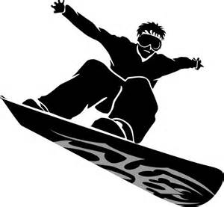
Every winter, snowboarders hit the slopes to try out new moves. If a snowboarder completes a “180” what has he done?

If a snowboarder completes a “360” what has she done?

If a snowboarder starts facing to the right, and completes a “720” which direction is he now facing? How do you know?

If a snowboarder starts facing to the left, and completes a “270” which direction is he now facing? How do you know?

Does it matter which direction the snowboarder starts to turn? In other words, does it matter if she’s heading clockwise or counter clockwise?

Trig Tour – Using Reference Angles with a Unit Circle
Part II – Explore
Explore Trig Tour for five minutes. Try to figure out what’s going on.
What patterns do you see?

Click on the Special Angles Button. What angles are marked? How do you know?

Click on the grid – what is the unit size of each line? What is the radius of the circle? How do you know?

Use the red dot to rotate around the circle. Watch the angles to see how they change. Describe the changes.

Repeat after clicking on the RADIANS button. Describe the changes to the angle.

At the end of the five minutes, you’ll be asked to share what you’ve noticed with your partner and then with the class.

Trig Tour – Using Reference Angles with a Unit Circle
Part III – Investigate
Using TrigTour, make your snowboarder complete spins to match the degrees or radians listed below. Then find the sine and cosine for each angle. If the angle is positive, the snowboarder moves in a counter clockwise direction. If the angle is negative, he moves in a clockwise direction.
Angle | Cos | Sin
-90°
720°
-360°
495°
405°
540°
-420°

Angle | Cos | Sin
$$\frac{13π}{2}$$
$$\frac{11π}{3}$$
$$-\frac{15π}{3}$$
$$\frac{14π}{4}$$
$$-\frac{17π}{6}$$
$$-\frac{19π}{4}$$
$$\frac{16π}{6}$$

Using Trig Tour, find two other angles that share the same values for BOTH sin and cos as the angle listed
Angle | Angle 1 | Angle 2
-90°
720°
-360°
495°
$$\frac{14π}{4}$$
$$\frac{17π}{6}$$
$$\frac{19π}{2}$$
$$\frac{16π}{6}$$

What patterns do you notice?

How could you easily find a second angle with the same value of sin and cos?

Trig Tour – Using Reference Angles with a Unit Circle
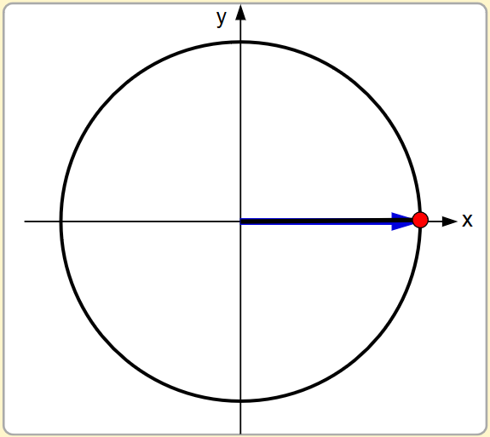
Part IV – Exit Ticket
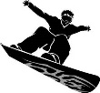
Mark does a “270” on his snowboard. Assuming he starts on the unit circle as shown, draw an arrow that shows his location at the end of the stunt.

Sally, who hasn’t been snowboarding nearly as long as Mark, says she can do the same thing…but she calls hers the ‘backwards 90.’ What might that look like? Would she end up at the same place?

Create a second option for each snowboard stunt that would be the same than the one listed:
The “240”

The backward $\frac{π}{3}$

