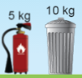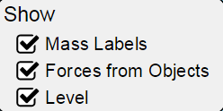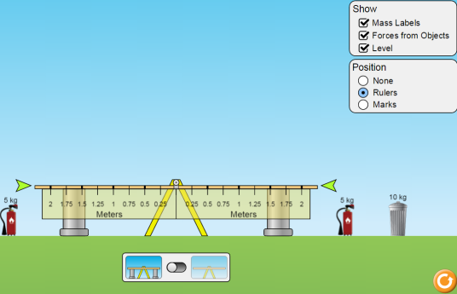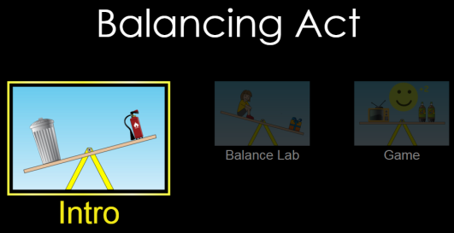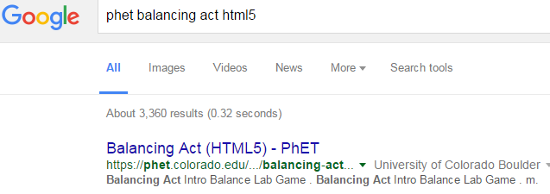

***Set-up***: Choose “Introduction”

Check all of the “show” boxes. 🡪

Add supports.

Choose 

**PhET Balancing Act html5**

CLICK!

***Part 1 Directions:*** Add masses to each side of the fulcrum. Remove supports and see if you are balanced. Draw 4 different ways to balance the masses. At least 2 of your pictures must use both the 10kg (100N) mass and one or two 5 kg (50N) masses. Use 1A and 1B as examples of bad (1A ☹) and good (1B ☺). For each side of the fulcrum, find the N*m as shown in 1A, 1B.

|  |  |
| --- | --- |
| 1A. **NOT BALANCED! ☹** | 1B.  **BALANCED!! ☺** |
| N*m:  50N*2m = 100N*m 50N*m =50N*1m  **≠** | N*m:  50N*0.5m = 25N*m  25N*m =50N*0.5m  **=** |
| 1C. | 1D |
| N*m:  **=** | N*m:  **=** |
| 1E. | 1F. |
| N*m:  **=** | N*m:  **=** |

***Part 1 Question:*** What do you notice about the N*m for your balanced masses?

AA31 Labs

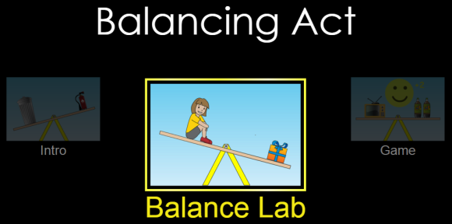

***Set-up***: Choose “Balance Lab”

Check all of the “show” boxes. 🡪

Add supports. 

Choose 



Your mission is to find the masses of ALL of the Mystery objects. Figure out the torque (N*m) for each mystery object and divide by the distance (m). Draw the balanced pictures, below.

|  |  |  |  |  |
| --- | --- | --- | --- | --- |
| **Mystery** | **Balancing pictures** | **What does each mystery object weigh? Show work here for each side…** | | |
| A.PNG |  | N  N  N  N  N  N  N  N  N  N | **=** |  |
| B.PNG |  |  | **=** |  |
| C.PNG |  |  | **=** |  |
| D.PNG |  |  | **=** |  |
| E.PNG |  |  | **=** |  |
| F.PNG |  | N | **=** | N |
| G.PNG |  | N  N  N | **=** | N |
| H.PNG |  | :  AA31 Labs | **=** |  |

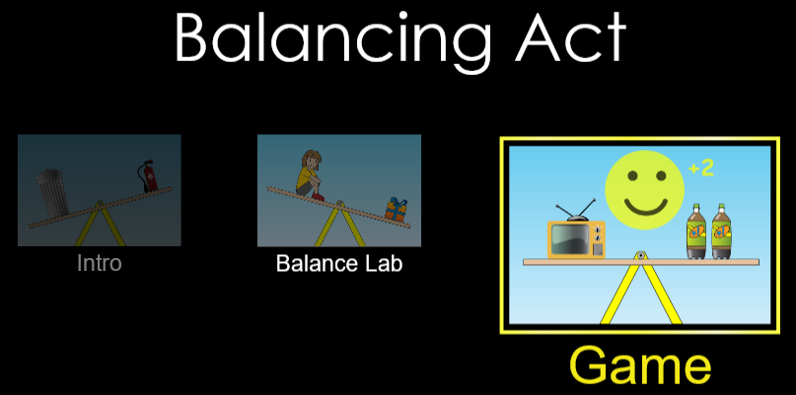

***Set-up***: Choose “Game”

Choose level:

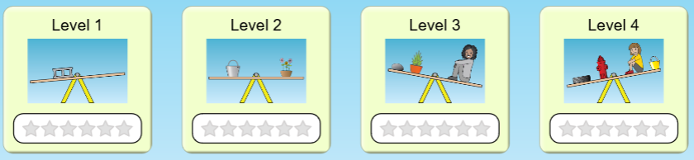

Play each level and record your best score in the boxes

|  |  |  |  |
| --- | --- | --- | --- |
| Best  Score | Best  Score | Best  Score | Best  Score |

***Post-lab Questions:***

Why do you think the simulation is called “Balancing Act”?

What are the two main factors in the weight on each side of the fulcrum?

What happens when the sides are not balanced?

***Going further:***

What real-life application(s) can you think of that can (and does) use the principles of this lab?

What are two occupations that this knowledge could be useful to have (outside of physics teacher…)?

AA31 Labs