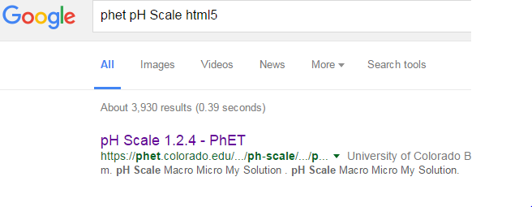
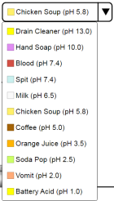
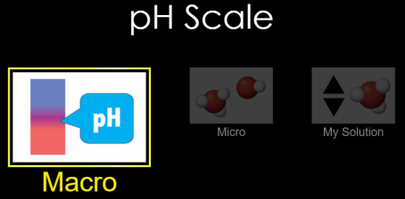
PhET pH scale html5
AA31 Labs
CLICK!
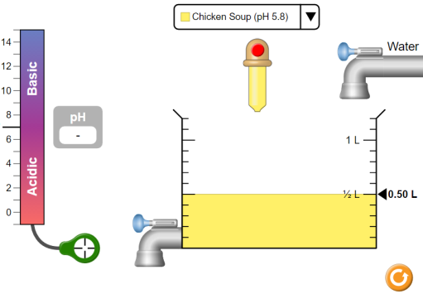
Setting up: The boxes in the picture, right, are pieces that move and affect the concentration and or amount of solution
Move the concentration sensor into the solution (circle, arrow)

Review the controls. Try them out, see what they
do. When done exploring them, click the reset button.

Part 1 Macro: Add some chicken soup to the beaker. How can you change the pH of the solution? _______________________________________________________________________________________________________________________________________________________________________________________________________________________________________________________________________________________
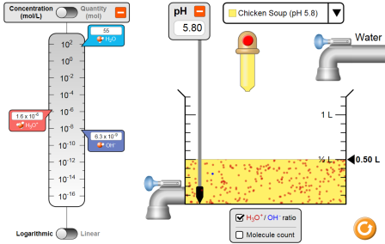
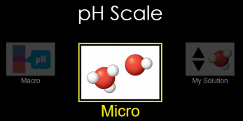
Part 2 Micro: Click then check
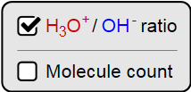
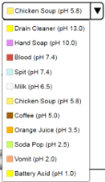

Choose the substance and fill in the table, below.

Substance | pH | Describe the dots | Concentration [H₃O⁺] | Concentration [OH⁻] | pOH  (14 - pH) | Classify  A – Acid  B – Base  N -- Neutral
Battery Acid | 1.00 | a. More red  b. Equal red and blue  c. More blue | 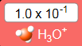 | 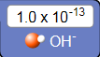 | 14 – 1 =  13 | A
Vomit |  | a. More red  b. Equal red and blue  c. More blue
Soda |  | a. More red  b. Equal red and blue  c. More blue
Coffee |  | a. More red  b. Equal red and blue  c. More blue
Milk |  | a. More red  b. Equal red and blue  c. More blue
Water |  | a. More red  b. Equal red and blue  c. More blue
Spit |  | a. More red  b. Equal red and blue  c. More blue
Blood |  | a. More red  b. Equal red and blue  c. More blue
Soap |  | a. More red  b. Equal red and blue  c. More blue
Drain Cleaner |  | a. More red  b. Equal red and blue  c. More blue

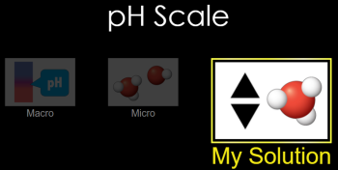
Part 3 pH Scale: Click then check the box
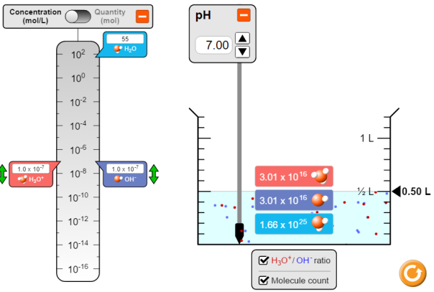
Fill in table following example:
example for pH7.
pH | [H₃O⁺] | [⁻OH] | Red/blue? | ABN
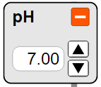 | 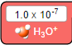 | 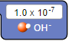 | equal | Neutral
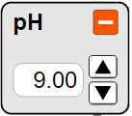 |  |  |  | Base
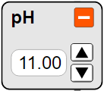
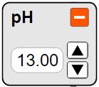
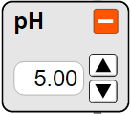 |  |  |  | Acid
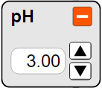
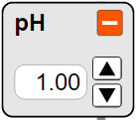

Post lab Questions:
In part 2, what relationship is there between pH and the dot color?

In part 2, what relationship is there between pH and the pOH?

In parts 2+3, what relationship is there between [H₃O⁺] and [⁻OH] (the sliders)?

In part 3, what relationship is there between pH and [H₃O⁺] (there is a cool numerical relationship!)?

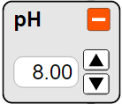
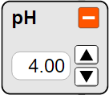
Going further
Using the data in part 3, predict what goes in the boxes:

Using the data from part 2, what would you predict the pOH’s to be for these entries in table 3?
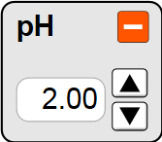 |  |  | pOH
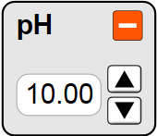 |  |  | pOH
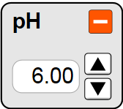 |  |  | pOH
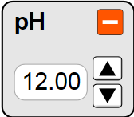 |  |  | pOH

Rate your understanding of pH
- :/
AA31 Labs

