Name: _______________________ Block: _________ Date: ___________
Go to: https://phet.colorado.edu/en/simulation/legacy/density
You should see: 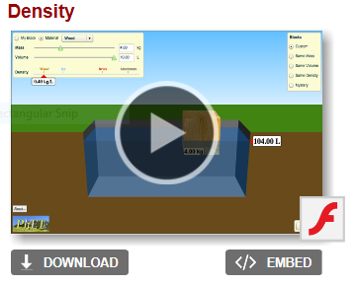
Click the play arrow. And you should see
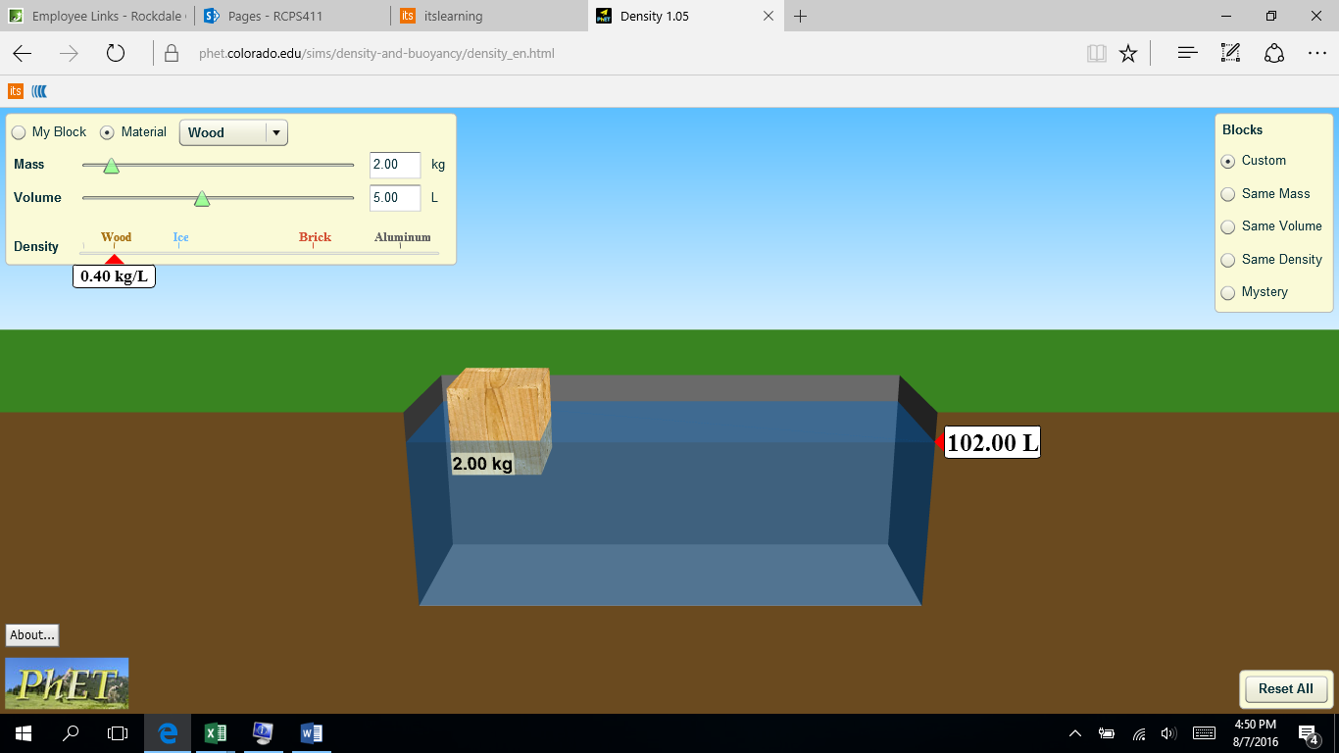
On the left select “Mystery” then you should see
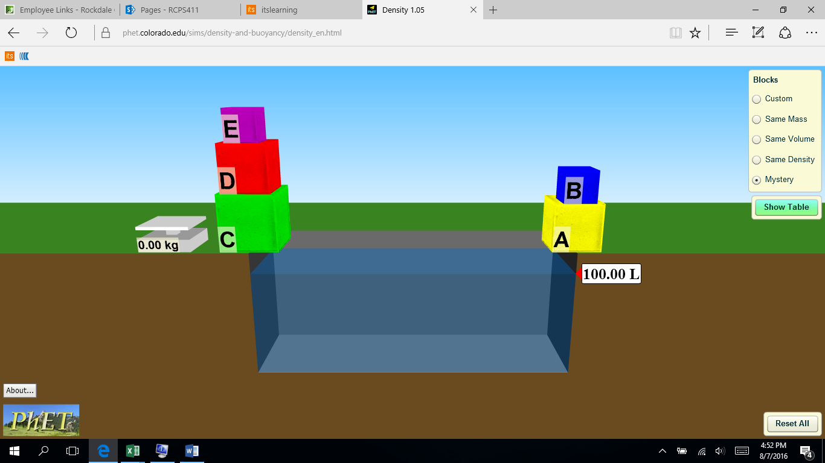
Based on What you see predict which block will float or sink and give a short reason in the table below.
Block | Float | Sink | Reasoning
A
B
C
D
E

Now for your lab.
- You can take a block and place it on the scale to the left in order to mass it. Record its mass in the table below.
- Once massed, place the block in the water and hold it at the bottom to find its volume by displacement. (Look at the volume meter on the right) Record its volume in the table below.
- Release the block to see if it sinks or floats. Check the appropriate box in the table.
- Remove the block and place it on the right.
- Repeat for all blocks.
- When finished, calculate the density of each block using the formula Density= ______________

Block | Mass | Volume | Density | Float | Sink
A
B
C
D
E

Data Analysis: If the density of water is 1.0 kg/mL, explain what your data shows

Click the tab that says “show table,” and identify what each block is made of.
Block | Material
A
B
C
D
E

