States of Matter Basics

Instructions
- When the simulation opens, go up to “Teacher” at the top and change temperature to Celsius.
- You will be on the Solid, Liquid, Gas tab for this simulation.
- There are three main interactive sections of this simulation:
a. Heating and cooling slider b. Atoms and Molecules c. Change State
(move up or down) (single choice) (single choice)
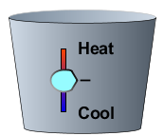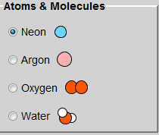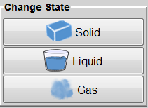

SECTION I
For the first activity, temperature will not be used. Choose Neon or Argon from the Atoms and Molecules choices. Change between the three states and diagram each atom behavior below.
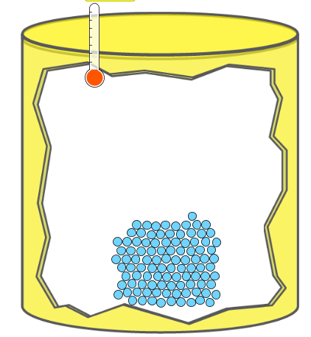
SOLID LIQUID GAS

SECTION 2
Using the Change State choices, identify the temperature in °Celsius for each state of matter for all four substances.

 | Neon (°C) | Argon (°C) | Oxygen (°C) | Water (°C)
Solid
Liquid
Gas

What physical properties does this simulation demonstrate? ___________________________________________________

_________________________________________________________________________________________________________________________

SECTION 3
Choose “solid” for each particle type and observe how the structures of solid oxygen molecules and solid water molecules differ from solid Neon and solid Argon molecules. Be specific as to volume, shape, and motion. _______________________________________________________________________________________________________________

_________________________________________________________________________________________________________________________

_________________________________________________________________________________________________________________________

_________________________________________________________________________________________________________________________

Use the Heating and Cooling slider to heat Argon to about 1200°Celsius. You notice fast moving and not so fast moving atoms – what happens to the atoms with slower motion? _____________________________________

_________________________________________________________________________________________________________________________

_________________________________________________________________________________________________________________________

Allow the container to remain at about 1200°Celsius for one minute. What happens to the container?

_________________________________________________________________________________________________________________________

Describe what happens to the atoms of Argon gas after the container is no longer intact. Be specific as to volume, shape, and motion of the particles. ______________________________________________________________________

_________________________________________________________________________________________________________________________

Draw a conclusion about how any gas particles behave when heated. Be specific as to volume, shape, and motion of the particles. _____________________________________________________________________________________________

_________________________________________________________________________________________________________________________

_________________________________________________________________________________________________________________________

SECTION 4
Use the Phase Change tab for this Section
Pressure is defined as a measure of the force applied over a unit area. A common example of pressure is psi, meaning “pounds per square inch.” In this simulation, the unit of pressure is the “atm.”

- Use the pump to investigate pressure in the container – describe what happens inside the container after 20 pumps of the pump handle. ________________________________________________________

________________________________________________________________________________________________________________

- How does the pressure gauge change after 20 pumps? __________________________________________________
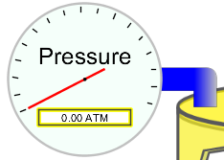
- How does the temperature gauge change after 20 pumps? _____________________________________________
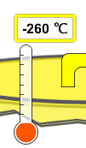
- Move the Heating and Cooling slider to heat the gases in the container. Describe what happens inside the container. Be specific as to volume, shape, and motion of the particles. ___________________

________________________________________________________________________________________________________________

________________________________________________________________________________________________________________

- Move the Heating and Cooling slider to cool water vapor in the container. Describe what happens inside the container. Be specific as to volume, shape, and motion of the particles. ___________________

________________________________________________________________________________________________________________

________________________________________________________________________________________________________________

- If you were to heat the water vapor in the container to the “overload” reading on the pressure gauge, predict what will happen to the container. ______________________________________________________

- Which causes the greatest increase in pressure inside the container: adding more particles with the pump or heating up the particles in the container? Explain. _______________________________________

________________________________________________________________________________________________________________

________________________________________________________________________________________________________________

- What could you do to prevent a container from exploding? Be specific as to temperature and pressure and describe the volume, shape, and motion of the particles during your preventative action. _________________________________________________________________________________________________________

________________________________________________________________________________________________________________

________________________________________________________________________________________________________________

- Describe two common applications or uses of pressure and the purpose for pressure. This could be in a job, recreation, etc. Describe how pressure is important to the activity in which it is used. _________________________________________________________________________________________________________________

_________________________________________________________________________________________________________________

