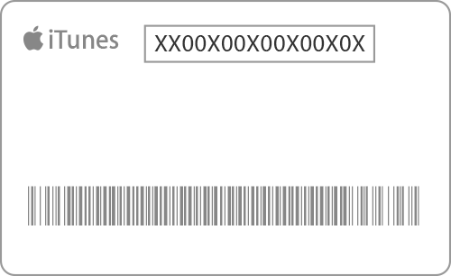
Station 2 :
20 credit points/sub-station
Content: 4 sub-station
Weight: 20 for each sub-station
To pass this station and get 100 extra credit points you are expected to choose 2 substations and describe in details what you have learned there and submit it by the end of the session.
Sub-station 1: Phet simulation
Open the following link: https://phet.colorado.edu/sims/html/build-an-atom/latest/build-an-atom_en.html
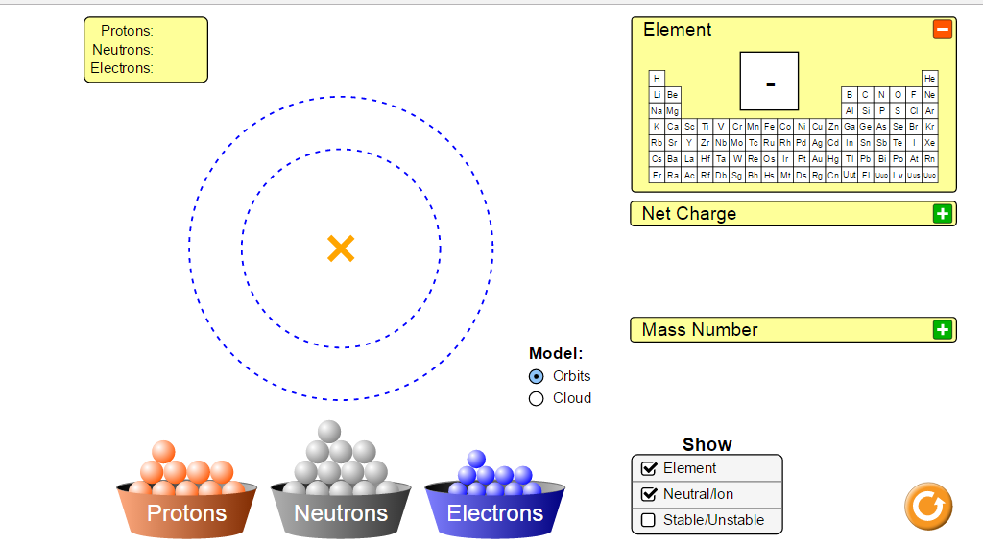
- Chose the "Atom" tab.
- Use the periodic table to build an atom of Beryllium.
- Start by adding protons first and then neutrons.
- What do you notice written on the upper right side of the atom?
..................................................................................................................................................................
- Add electrons to your model . what is written right now next to the atom ? Explain
..................................................................................................................................................................
..................................................................................................................................................................
- Add one more electron to the atom, what has changed now? What do you notice now in the "Net Charge" box?
..................................................................................................................................................................
..................................................................................................................................................................
- Could you write now the element notation and put the charge on it?

- Take away the extra electron you added in addition to the two outermost electrons. What do you notice now in the net charge box? Explain the difference between what you seen in the "Net Charge" box in steps 6 and 7.
..................................................................................................................................................................
..................................................................................................................................................................
..................................................................................................................................................................
..................................................................................................................................................................
..................................................................................................................................................................
Move now to the Symbol tab
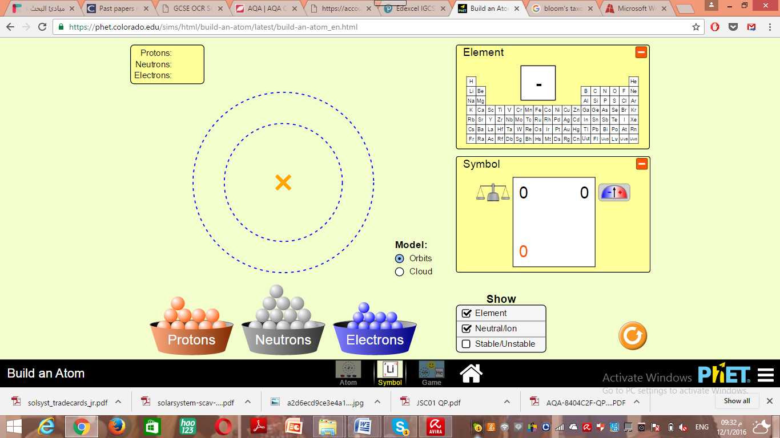

Now you can check whether the element notation you did in step 7 is correct or not.
-.Build the neutral atom of Beryllium, take away the outer most electrons and record the element notation in box 1 below, add one extra electron to the neutral atom and record the element notation in box 2. Compare between both notation. Why are they different?

Box 1 Box 2
 | Box 1 – electrons removed | Box 2- electron added
- Proton number
- Mass Number
- Charge

