AP Intro to Circuits Lab
Open the Circuit Construction Kit on the PhET site.
You will be using this site for a couple of labs. On this simulation, you will be able to choose from “life-like” or “schematic” views of the circuits. You may view either on the simulation but you may only DRAW schematics on your papers. Schematics are the proper way to draw circuits, no life-like drawings will be awarded credit.
Life-like | schematic | tools to use to measure the current flow through wires and the potential difference across batteries, lightbulbs and resistors
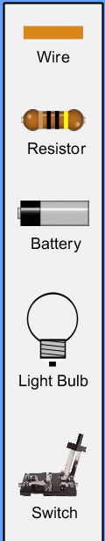 | 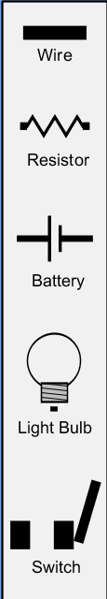 | 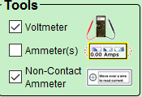
Rules for drawing schematics:
- NEVER place an item at the junction of 2 or more wires. It makes it difficult to trace the path of the current
- Always attach a wire between 2 items in the circuit.
- Make the corners of your circuit square. Do not fill your drawing with trapezoids and triangles. This also makes for confusing schematic drawings.
Construct a circuit like the one shown below. Right click on the battery and change the voltage to 20 Volts. If it isn’t already, connect the battery. All the light bulbs should light up. 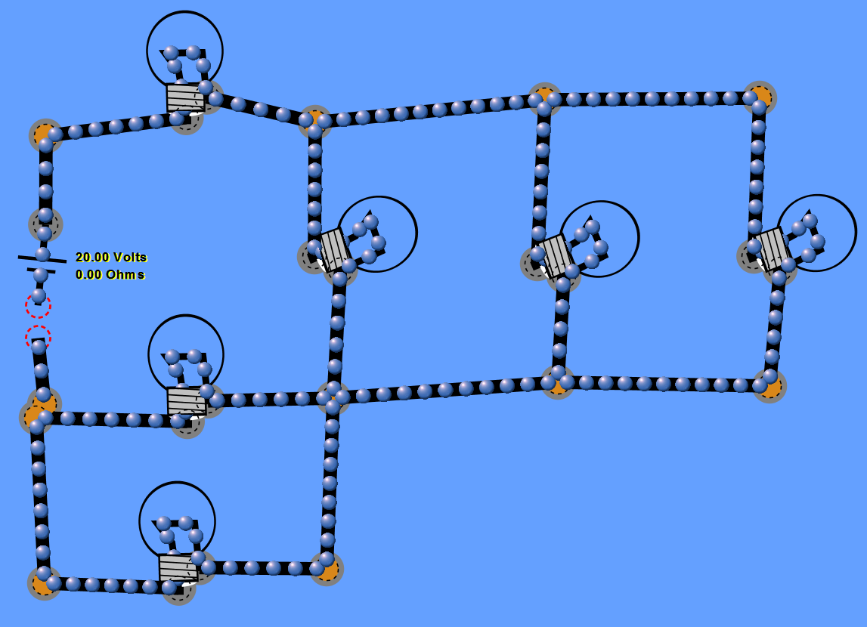
Use the non-contact ammeter to measure the flow of the current through each of the wires at the locations indicated on the circuit below. Record the readings you make AND draw an arrow showing the direction the current is flowing through the wire at that location.
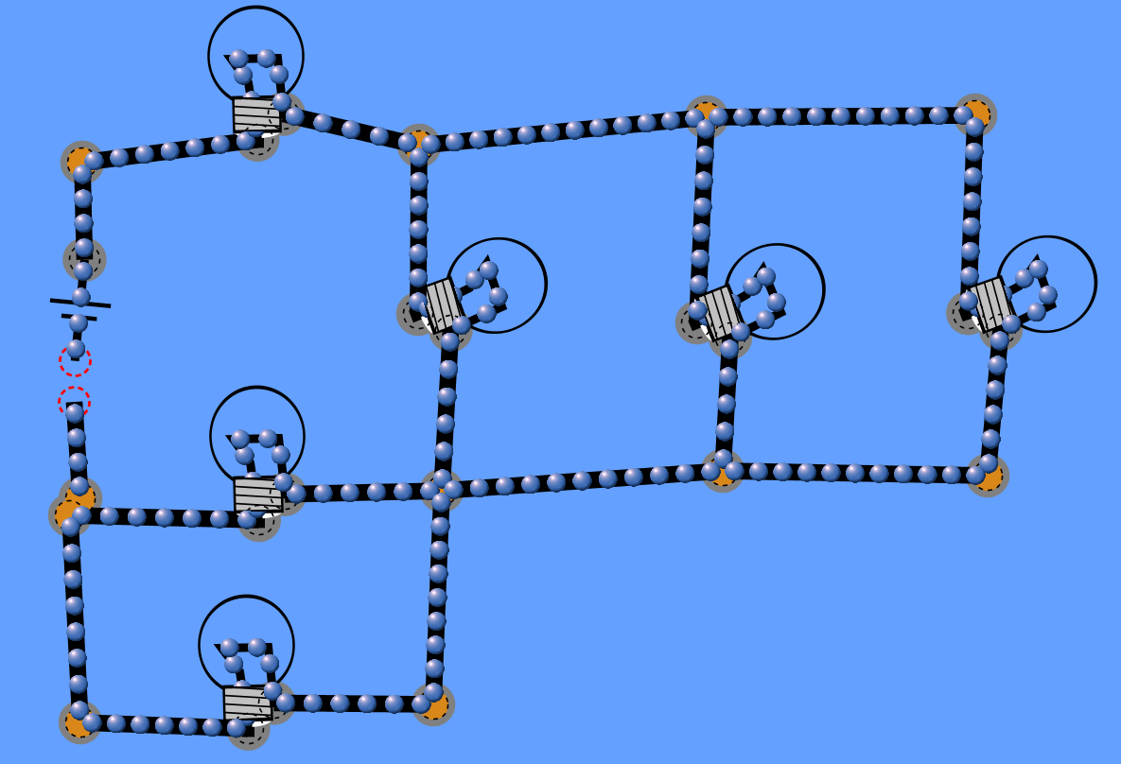
D
C
E
B
A
- Right click on the battery again, this time select “reverse”. The battery flips orientation and the direction of current reverses. How does this change the magnitude of the current flowing through the wires?

- How does the current flowing INTO the battery compare with the current flowing OUT of the battery? Does the battery create new current? Use evidence to justify your answer.

- How does the current flowing INTO the lightbulb compare with the current flowing OUT of the lightbulb? Does the lightbulb use up the current? Use evidence to justify your answer.

- Using your data from above, evaluate the current flow through a junction. Complete the following table with the current reading and the direction the current flows (IN or OUT of the junction) for all the wires at an intersection.
junction | Current in amps and direction | Current in amps and direction | Current in amps and direction | Current in amps and direction
A
B
C
D
E

- Write a paragraph explaining how the current flowing into a junction compares to the current flowing out of a junction. Use the definition of “current” and the Law of Conservation of Charge to justify your findings.

