Name_______________________________________ Date_____________
Sugar and Salt Solutions PhET – Introduction to Solutions

Goal: you will be able to

1). Compare and contrast the behavior of molecular compounds and chemical salts in water.

2). Provide evidence to classify molecular compounds and chemical salts as either as electrolytes or non electrolytes

3). Draw particle diagrams that represent aqueous solutions of chemical salts in water and molecular compounds in water

4). Propose an explanation of the behavior of the conductivity tester in the salt and sugar solutions.

Getting Familiar with the Program – Macro Screen
Shaker to dispense sugar and salt
Provides the number of particles in solution
Toggle between sugar and salt
Adds water from the beaker

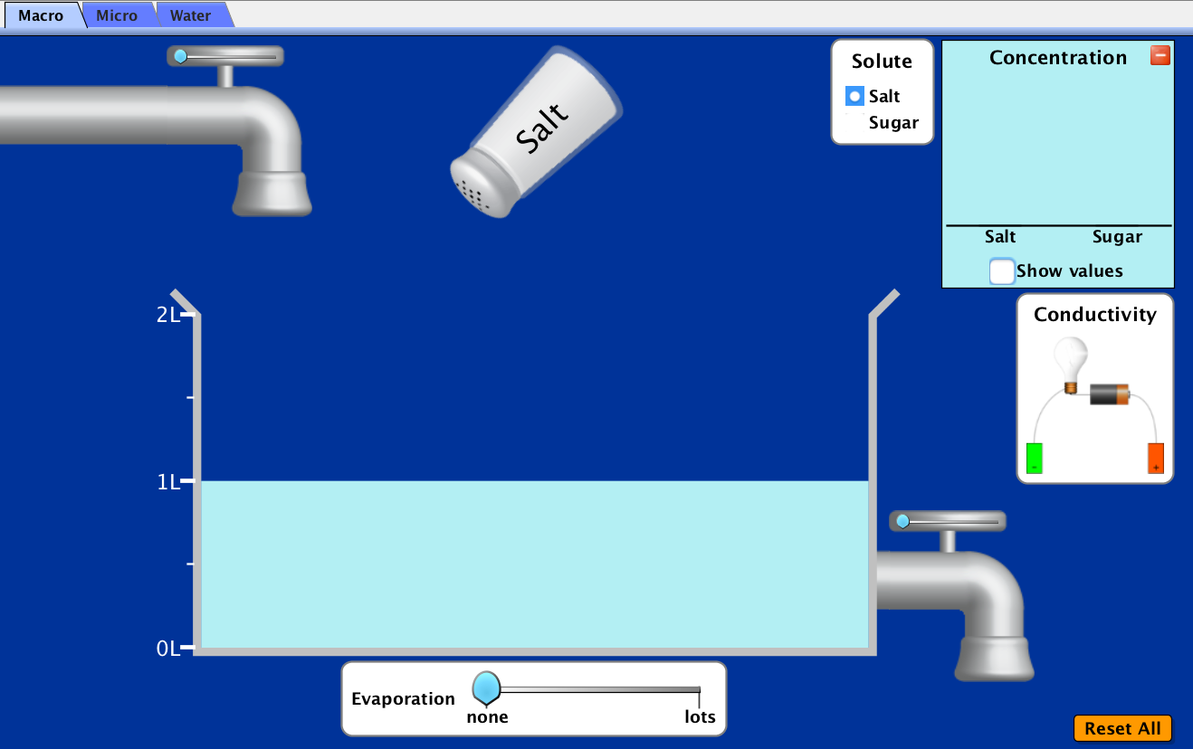

Place this in the solution to determine conductivity

Reset Button
Removes water from the beaker
Evaporates water from the beaker

- Take a moment to play with the controls before moving on to the procedure!
- Select the Reset All button before proceeding
Procedure

- Make sure the solute is selected to salt

1). Pick up the conductivity tester and place it in the water in the beaker. Record your initial observations of the behavior of the light bulb in the water.

_______________________________________________________________________
2). Do 1 shake of salt into the water. What do you observe about the light bulb?

_______________________________________________________________________
_______________________________________________________________________

3). Add another shake into the water. Record your observations.

_______________________________________________________________________
_______________________________________________________________________

4). Add additional shakes of salt into water. Continue to record your observations.

_______________________________________________________________________
_______________________________________________________________________
There are three variables for you to consider.

- Adding water
- Removing water
- Evaporating water

Select one variable and record it in the space provided

Variable: _____________________

Proceed with adjusting this variable and record the observation of the light bulb.

_______________________________________________________________________
_______________________________________________________________________
Select a different variable and record it in the space provided. Add more salt to the water if necessary.

Variable: _____________________

Proceed with adjusting this variable and record the observation of the light bulb.

_______________________________________________________________________
_______________________________________________________________________
_______________________________________________________________________

Select the last variable and record it in the space provided. Add more salt to the water if necessary.

Variable: _____________________

Proceed with adjusting this variable and record the observation of the light bulb.

_______________________________________________________________________
_______________________________________________________________________
_______________________________________________________________________

Select the Reset All Tab

- Change the solute from salt to sugar

1). Pick up the conductivity tester and place it in the water in the beaker. Record your initial observations.

_______________________________________________________________________

2). Do 1 shake of sugar into the water. What do you observe about the light bulb?

_______________________________________________________________________
3). Add another shake into the water. Record your observations.

_______________________________________________________________________

4). Add additional shakes of sugar into water. Continue to record your observations.

_______________________________________________________________________

Consider the three variables previously listed.

- Adding water
- Removing water
- Evaporating water

Modify each variable with the sugar water mixture. Record the observations of the light bulb.

_______________________________________________________________________
_______________________________________________________________________
_______________________________________________________________________

Define the following terms:

Solute:

_______________________________________________________________________
_______________________________________________________________________

Solvent:

_______________________________________________________________________
_______________________________________________________________________

Solution:

_______________________________________________________________________
_______________________________________________________________________

Electrolyte (look up the definition in the class set of review books)

_______________________________________________________________________
_______________________________________________________________________

Non-Electrolyte (look up the definition in the class set of review books)

_______________________________________________________________________
_______________________________________________________________________

Based on the above definitions, consider water, salt and sugar

- Make a claim identifying the solute(s) in this simulation

_______________________________________________________________________
Provide evidence to support your claim:

_______________________________________________________________________
_______________________________________________________________________

- Make a claim identifying the solvent(s) in this simulation

_______________________________________________________________________
Provide evidence to support your claim:

_______________________________________________________________________
_______________________________________________________________________

Switch the top tab to Micro

- In the solute box, make sure that the selected solute is sodium chloride

1). Add 1 shake of sodium chloride into the water.

How does the sodium chloride appear prior to entering the water?

_______________________________________________________________________
_______________________________________________________________________
_______________________________________________________________________
Draw a particle diagram of your observations in the space below. If necessary, reset this simulation to see the sodium chloride again.

How does the sodium chloride appear once it has entered the water?

_______________________________________________________________________
_______________________________________________________________________
_______________________________________________________________________
Draw a particle diagram of your observations in the space below.

Describe the ratio of sodium ions to chloride ions that appears in the concentration box

_______________________________________________________________________
Understanding the Dissolution of NaCl

What type of intramolecular force (chemical bonding) occurs within NaCl(s)?

_______________________________________________________________________

Do any intermolecular forces occur in NaCl(s)?

_______________________________________________________________________

Write the dissolution equation for sodium chloride dissolving in water. Make sure to use the labels (s) for solid and (aq) for particles in the aqueous solution

_______________________________________________________________________

Are the particles in the water atoms or ions? How can you tell?

_______________________________________________________________________
_______________________________________________________________________

When the solid is added to the water, individual sodium and chloride ions are formed. Is this a physical or chemical change?

_______________________________________________________________________

Evaporate all the water from the beaker. What happens to the particles in the water? Is this a physical or chemical change? Justify your answer by providing evidence from your observations.

_______________________________________________________________________
_______________________________________________________________________
_______________________________________________________________________
Refer back to your answers from the previous Macro Tab

Review your answers from the activity with the conductivity tester and the NaCl(aq). Provide a reason using evidence that you have gathered to explain why the light bulb lit up in the NaCl(aq) solution.

_______________________________________________________________________
_______________________________________________________________________
_______________________________________________________________________
_______________________________________________________________________
Return back to the Micro Tab and Select Reset All

- In the solute box, make sure that the selected solute is sucrose (C₁₂H₂₂O₁₁)

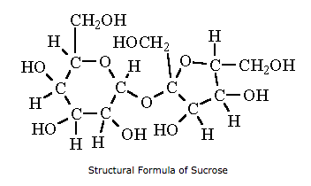

1). Add 1 shake of sucrose into the water.

How does the sucrose appear prior to entering the water? (A general description is acceptable)

_______________________________________________________________________
_______________________________________________________________________
Draw a (general) particle diagram of your observations in the space below. If necessary, reset this simulation to see the sucrose molecule again. It does NOT need to have a correct molecular structure.

How does the sucrose appear once it has entered the water?

_______________________________________________________________________
_______________________________________________________________________
Draw a particle diagram of your observations in the space below. Again, it does NOT need to have a correct molecular structure.

Understanding the Dissolution of Sucrose (C₁₂H₂₂O₁₁)

What type of intramolecular forces (chemical bonding) occurs within the sucrose molecule?

_______________________________________________________________________

Write the dissolution equation for sucrose (C₁₂H₂₂O₁₁) dissolving in water. Make sure to use the labels (s) for solid and (aq) for particles in the aqueous solution

_______________________________________________________________________

Are the particles in the water atoms or ions or molecules? How can you tell?

_______________________________________________________________________
_______________________________________________________________________

When the solid is added to the water, individual molecules of sucrose are formed. Is this a physical or chemical change?

_______________________________________________________________________

Evaporate all the water from the beaker. What happens to the particles of sucrose? Is this a physical or chemical change? Justify your answer by providing evidence from your observations.

_______________________________________________________________________
_______________________________________________________________________

As the sucrose is added to the beaker, the substance changes from larger substances to smaller substances. In general, what is breaking when this process occurs?

_______________________________________________________________________
_______________________________________________________________________

Refer back to your answers from the previous Macro Tab

Review your answers from the activity with the conductivity tester and the aqueous sucrose solution. Provide a reason using evidence that you have gathered to explain why the light bulb did not light up in the C₁₂H₂₂O₁₁(aq) solution.

_______________________________________________________________________
_______________________________________________________________________
_______________________________________________________________________

Return to the simulation. Select the Micro tab. In the solute box, select the yellow circle with the black arrow to advance to the next set of solutes. Select calcium chloride (CaCl₂).

- Shake the calcium chloride into the water

Describe the ratio of calcium ions to chloride ions

_______________________________________________________________________

If the conductivity tester was placed in this solution, do you think the light bulb would light up? Make a connection to the previous NaCl(aq) solution and the sucrose solution situations.

_______________________________________________________________________
_______________________________________________________________________
_______________________________________________________________________
In the solute box, select the yellow circle with the black arrow and advance to the next set of solutes. Select sodium nitrate (NaNO₃).

- Shake the sodium nitrate into the water

Describe the ratio of sodium ions to nitrate ions in solution

_______________________________________________________________________
What makes this solution different from the previous solutions in terms of ions present?

_______________________________________________________________________
Switch the top tab to Water

In the Show box in the bottom right hand corner, make sure both the water partial charges and the sugar highlight boxes are checked.

- Pick up the salt crystal and drop it in the middle of the screen.

Describe what occurs. If the ions immediately move off the screen, select the reset all button and add the sodium chloride again.

_______________________________________________________________________
_______________________________________________________________________
_______________________________________________________________________

Pause the simulation and observe the orientation of the water molecules around the sodium ion and the chloride ion.

- Using structural models of water, draw what you observe using one sodium ion and one chloride ion. This type of interaction is call ion-molecule forces of attraction.

Select Reset All on this screen

In the Show box in the bottom right hand corner, make sure both the water partial charges and the sugar highlight boxes are checked.

- Pick up the sugar crystal and drop it in the middle of the screen.

Describe what occurs. If the molecules immediately move off the screen, select the reset all button and add the sugar again.

_______________________________________________________________________
_______________________________________________________________________
_______________________________________________________________________

