Exploring electric charges – simulations
Warm-up: Fill in the table with the descriptions of each particle.
 | Electron | Proton | Neutron
Relative size/
Charge
Can it move?
Activities: explore the fundamentals of charge and the interactions between charges
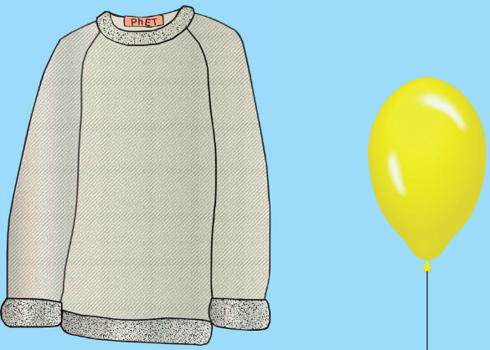
Go to the Canvas Calendar, and click on today’s date. The links for these activities are provided for you there. These activity pages will be collected at the end of class. You will work individually on these activities.
Part 1: Balloons
- Using the picture on the right, draw the charges that you see when you open the simulation. Then fill in the table. To get overall charge, subtract # of negative charges form # of positive charges.
Charges of Balloon and Sweater before moving
 | Balloon | Sweater
# of positive charges
# of negative charges
Overall Charge

- Click on the balloon and drag to rub the balloon against the sweater, then record your new results in the table to the left.
Charges of Balloon and Sweater AFTER moving
 | Balloon | Sweater
# of positive charges
# of negative charges
Overall Charge

- When I rub the balloon against the sweater, what happens? Fill in the table below
The charges that can move are the

Rubbing the balloon against the sweater does what to the electrons of the sweater?
Is the balloon material an insulator or a conductor?
Of what kinds of charge does the balloon have extra?
What, therefore, is the charge of the balloon?
Of what kinds of charge is the sweater lacking?
What, therefore, is the charge of the sweater?
- Click and drag the balloon to the center of the screen, then release the mouse. What happens? Explain why in terms of charges.
- Notice the wall on the right side of the screen? There are 54 positive charges and 54 negative charges in the wall. What is the overall charge of the wall? ____________________

- Make a hypothesis: What do you think will happen if you bring the balloon with all those negative charges over to the neutral wall? Circle one choice from below:
Attract Repel Nothing
- Make an observation: Click on the balloon and slowly drag it towards the wall. What happens as it gets closer to the wall?

Can electrons move?
Can protons move?

What do like charges do?
What do the electrons in the wall do when the balloon comes closer? Why?
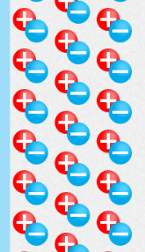
- Draw what the charges in the wall do when the balloon comes closer to the wall.
Wall

This process of separating charges temporarily is call polarization.
Polarization is how a charged object can be attracted to a neutral one.
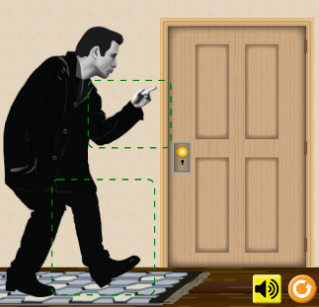
Part 2: John Travoltage
- Predict what will happen to John if he rubs his foot against the carpet.
- Rub John’s foot on the carpet by clicking and dragging his foot few times. What happens? (Explain in terms of electrons)
- After rubbing John’s foot on the carpet, click and drag John’s hand such that it touched the doorknob. What happened? (be specific)
- How is this simulation different from the balloon and sweater or balloon and wall touching each other?
What we find in this activity is that when an excess of charges build up, they want to go back to a balanced, or neutral state. When an excess of charge is “dumped” into a conductor, we see a spark or a shock. The doorknob in this activity is referred to as a ground. A ground is a place where we can dump excess charge.
Post-Lab Questions: Write the letter of the correct answer on the blank provided.

_____ 1. Over time, all the negative charges in an object,
a. remain clustered together where they were placed.
b. spread out over a small area on the object.
c. spread out over a large area on the object.

_____ 2. When a charged object touches a conductor (like a door knob),
a. the positive charges move to the conductor and exit the object.
b. the negative charges move to the conductor and exit the object.
c. both the positive and negative charges move to the conductor and exit the object.
d. neither the positive nor the negative charges move to the conductor and exit the object.

_____ 3. Based upon what you saw in this lab, then, it can be said that
a. a person cannot be shocked if they have an excess charge on them.
b. a person cannot be shocked if they have neutral charge.
c. a person can be shocked at any time because it doesn’t depend on the charge the person has.
Part 3: Electric field Hockey
The goal of this game is to get the black positive puck to go in the goal.
To play, click and drag the blue or red charges down onto the “table”

- Draw where you can you set up just one negative charge to score a goal? (Remember to hit start)

A Positive and a negative charge will _______________________

- Draw where you can you set up just one positive charge to score a goal? (Remember to hit start)

A Positive and a Positive charge with _______________________

- Put one positive charge on the surface and one negative charge directly below it. Then check the box that says “field”. Draw what you see on the screen. These arrows represent the electric field lines.
Now play the game.
Set difficulty to 1, then 2, then 3. When you beat each level, draw your set up, and show me. Hint: leaving the field box checked might help you
Level 1 set-up
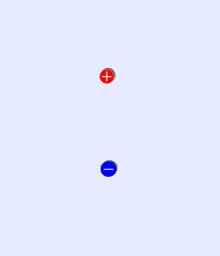

Complete the Ultimate Wrap-up questions before you try levels 2 and 3. This activity is graded, but you can still receive full credit if everything is done except for levels 2 and 3.
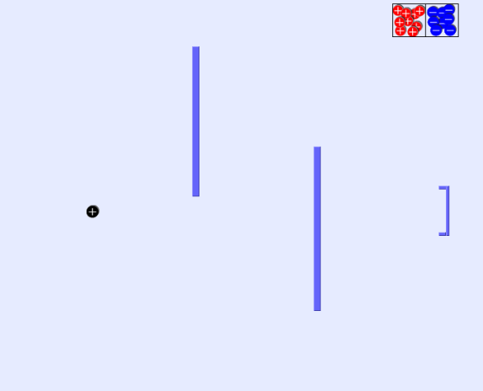
Level 2 set up: Level 3 set up:
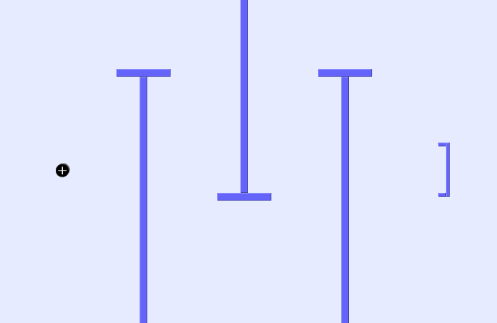

Ultimate Wrap-up:
- What charges move? __________________________________
- What is polarization?
- Does a polarized object change its overall charge? ___________________
- Why do “shocks” happen?
Copper pipes are often used to carry water. This is why people recommend against showering in a lightning storm. Every house has a metal fitting around the copper pipes, which is connected to a wire that goes outside and is buried in the ground. How does this buried ground wire keep your house safer?

