Name: ____________________________________________________________________ Date: ________________
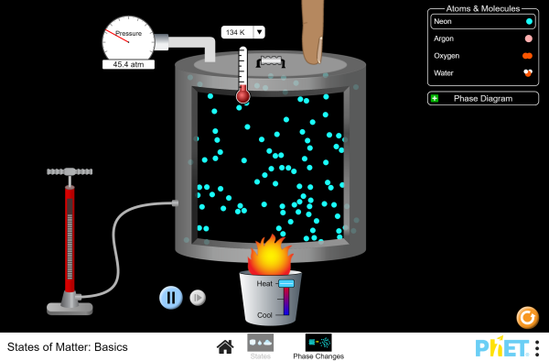
Gas Laws Simulation Lab

- Go to Phet.colorado.edu
- Search for the “States of Matter: Basics” simulation.
- Click on the “Phase Changes” icon.
- Select “Oxygen.”

- The simulation shows a quantity of oxygen molecules. What state of matter is this?
- How do you know?

- Heat the oxygen to about 150 K. What state of matter is this?
- How do you know?

Experiment One: Constant volume.
- Leave the oxygen at 150 K. In the table below, record the pressure and temperature of the oxygen in the first row.
- Heat the oxygen to about 450 K.
- Record the new temperature and pressure in the second row of the table.
- Heat the oxygen to about 900 K.
- Record the new temperature and pressure in the third row of the table.
Temperature vs. pressure at constant volume
Temperature (K) | Pressure (atm)

- Write a statement describing how the temperature of a quantity of a gas is related to its pressure at constant volume.

- Draw a graph illustrating this relationship, with temperature on the x-axis and pressure on the y-axis. Label the axes and give the graph a title. You do not have to scale the axes.

Experiment two: Constant temperature.
- Reset the simulation and choose oxygen.
- Heat the oxygen to 450 K.
- We will call the current volume of the oxygen “1 container.” In the table below, record the volume and pressure of the oxygen in the first row.
- Drag the finger down to decrease the volume to 1/2 of a container. Cool the oxygen to 450 K. Record the new volume and pressure in the second row of the table.
- Drag the finger down to decrease the volume to 1/4 of a container. Cool the oxygen to 450 K. (This may take a while. Be patient!) Record the new volume and pressure in the third row of the table.
Volume vs. pressure at constant temperature
Volume (containers) | Pressure (atm)

- Write a statement describing how the volume of a quantity of a gas is related to its pressure at constant temperature.

- Draw a graph illustrating this relationship, with volume on the x-axis and pressure on the y-axis. Label the axes and give the graph a title. You do not have to scale the axes.

Experiment three: Constant pressure.
- Reset the simulation and choose oxygen.
- Drag the finger down until the pressure is about 100 atm. (The pressure will not change at first. Experiment!)
- In the table below, record the temperature and volume of the oxygen in the first row. (Estimate the volume as a fraction of a container.)
- Drag the finger upward to increase to volume to 1/2 a container. Heat the oxygen until the pressure is once more at 100 atm. (Be patient!) Record the new temperature and volume in the second row of the table.
- Drag the finger upward to increase to volume to 1 container. Heat the oxygen until the pressure is once more at 100 atm. (Be very patient!) Record the new temperature and volume in the third row of the table.
Temperature vs. volume at constant pressure
Temperature (K) | Volume (container)

- Write a statement describing how the temperature of a quantity of a gas is related to its volume at constant pressure.

- Draw a graph illustrating this relationship, with temperature on the x-axis and volume on the y-axis. Label the axes and give the graph a title. You do not have to scale the axes.

Extension question:
- The gas laws are true for a fixed quantity of gas. With this in mind, explain why we didn’t use the bicycle pump for this activity.

